Stevens Institute of Technology
School of Business

AACSB
ASSURANCE OF LEARNING PLAN

Graduate Management Program:
Master of Science in Technology Management (MSTM)
&
Executive Masters in Business Administration (EMBA)
INDIRECT GOALS- Exit Surveys
MSTM /EMBA- 1: Written Communication Skills & Presentation Skills
MSTM/EMBA 2: Interacting in Teams
MSTM/EMBA- 3: Use of Technology for Competitive Advantage
MSTM/EMBA – 4: Critical and Strategic Thinking Skills
Responsibility: Brian Rothschild

June 24, 2024
Table of Contents

1. Indirect Measurements for Competency Goals MSTM/EMBA 1, MSTM/EMBA 2, MSTM/EMBA 3, MSTM/EMBA 4 …..…..3-4
2. Results- Graduate Exit Survey
May 2024 ……………………………………………………………………5-9
May 2023 ……………………………………………………………………10-13
3. Continuous Improvement Record 13

10. Indirect Measurements
Competency goal | Indirect Measurements
MSTM/EMBA – 1. Students can communicate effectively in writing and oral presentations. | We will conduct a survey of recent graduates to obtain their perspective on the extent to which their studies helped them develop in relation to MSTM/EMBA Competency goals. For each goal, we will pose three questions focusing on graduates’ knowledge and skills efficacy/confidence and two open ended questions will ask them to describe the ways in which what they learned are relevant to their current work and activities. We anticipate surveying 10-20 graduates. We expect the questions asked to evolve over time.
MSTM/EMBA – 2. Students can interact effectively in teams. | Indirect measurements will be taken at periodic intervals. Depending on the measurement chosen, a diagnostic tool will be selected for analysis. One possibility is interviews. The interview will be structured, with representative team members. The structured interview will gather information about the key competencies. The responses will be subjected to a content analysis. Another option for the future is employer/supervisor feedback about the students’ teamwork skills.  Additionally, we will conduct a survey of recent graduates to obtain their perspective on the extent to which their studies helped them develop in relation to MSTM/EMBA Competency goals. For each goal, we will pose three questions focusing on graduates’ knowledge and skills efficacy/confidence and two open ended questions will ask them to describe the ways in which what they learned are relevant to their current work and activities. We anticipate surveying 10-20 graduates. We expect the questions asked to evolve over time.
MSTM/EMBA – 3. Students will develop, articulate and put into practice technology strategies aligned with corporate mission, and business strategy. | Survey of supervisors of student interns/coop members/CPT students/ICP participants: Working with all faculty members supervising these experiential opportunities, survey the supervisors on their strategic thinking and creative identification of application of technologies at the sponsoring organization.  Additionally, we will conduct a survey of recent graduates to obtain their perspective on the extent to which their studies helped them develop in relation to MSTM/EMBA Competency goals. For each goal, we will pose three questions focusing on graduates’ knowledge and skills efficacy/confidence and two open ended questions will ask them to describe the ways in which what they learned are relevant to their current work and activities. We anticipate surveying 10-20 graduates. We expect the questions asked to evolve over time.
MSTM/EMBA – 4. Students can identify, assess, launch, and lead organizational strategic initiatives in a technology-based environment for the creation of new business models (i.e., corporate entrepreneuring) in a large corporation including both sustaining and disruptive businesses. | The first trait will be measured by an executive champion, required for every project, in the students’ company. The second trait will be measured by executives who are external to the company and evaluate the project as part of the last class.  Additionally, we will conduct a survey of recent graduates to obtain their perspective on the extent to which their studies helped them develop in relation to MSTM/EMBA Competency goals. For each goal, we will pose three questions focusing on graduates’ knowledge and skills efficacy/confidence and two open ended questions will ask them to describe the ways in which what they learned are relevant to their current work and activities. We anticipate surveying 10-20 graduates. We expect the questions asked to evolve over time.

2. RESULTS – GRADUATE EXIT SURVEY
Exit survey conducted in May 2024
Additional Goal 1: Written Communication Skills & Presentation Skills
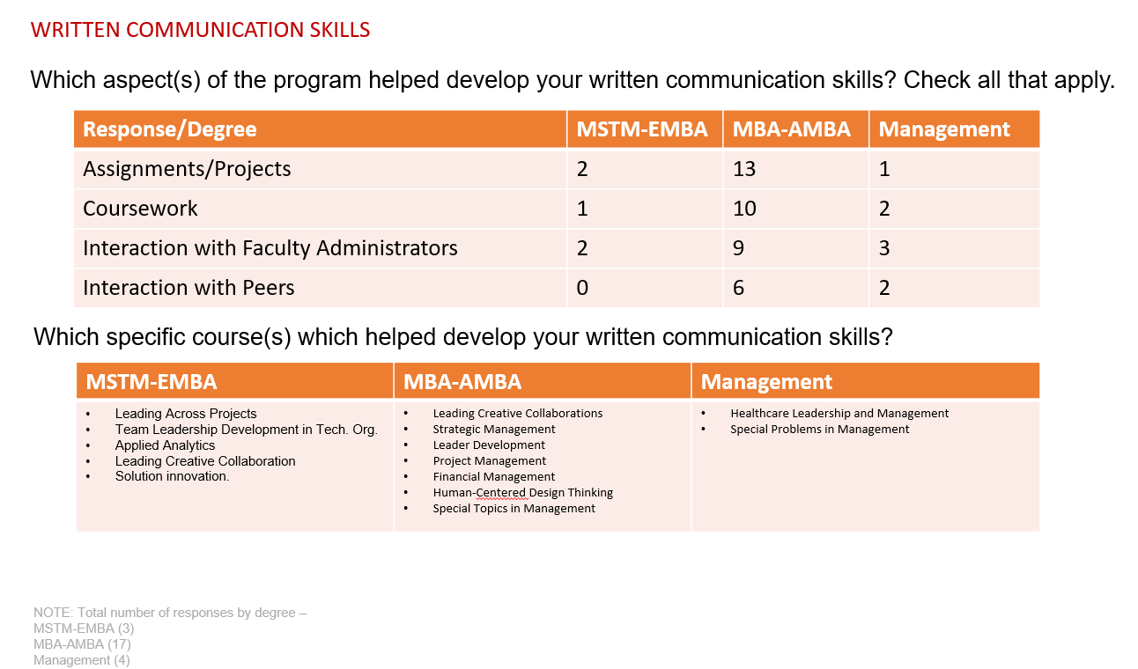
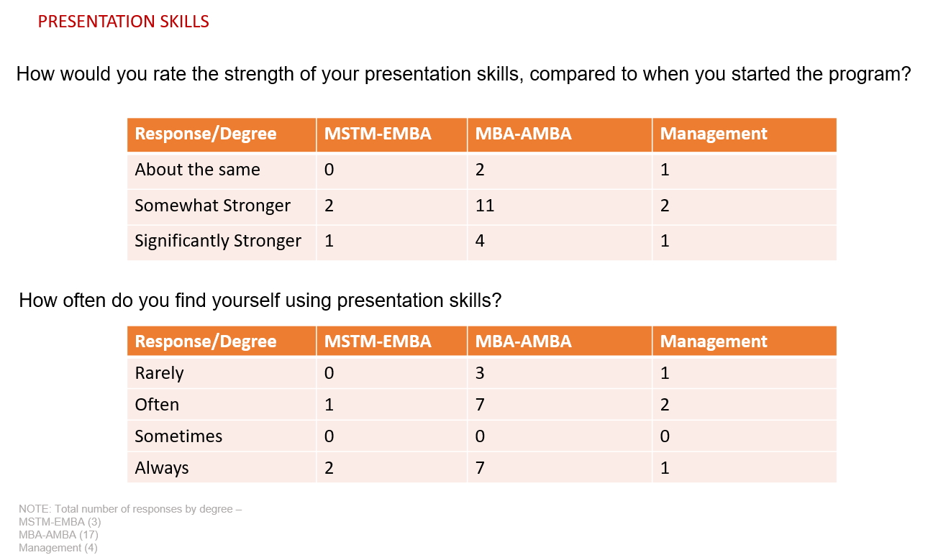

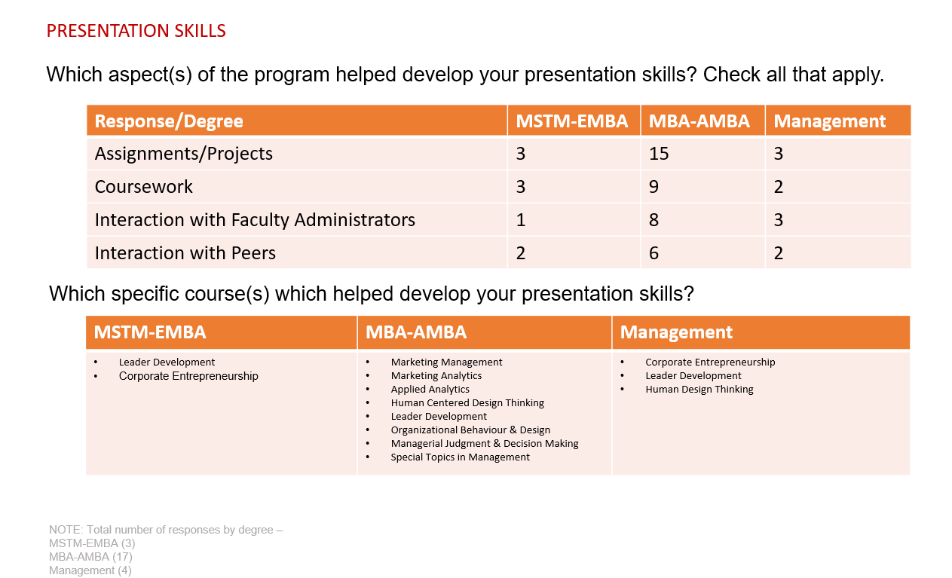
Additional Goal 2: Students can interact effectively in teams.
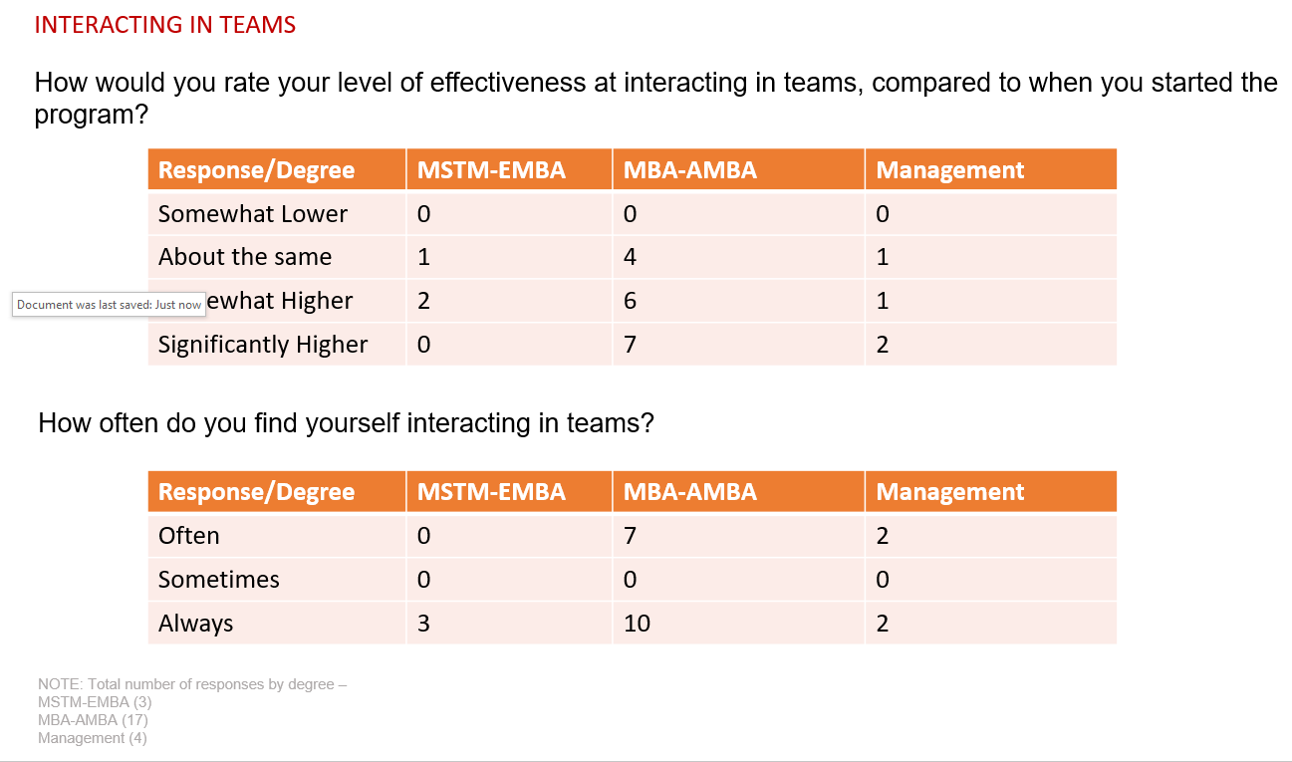

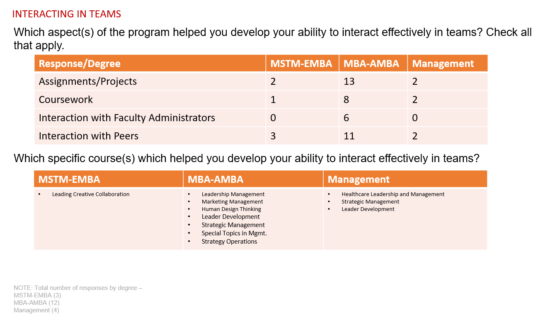
Additional Goal 3: Our students will be able to develop and analyze descriptive, predictive, and prescriptive models using software tools to aid in decision-making.
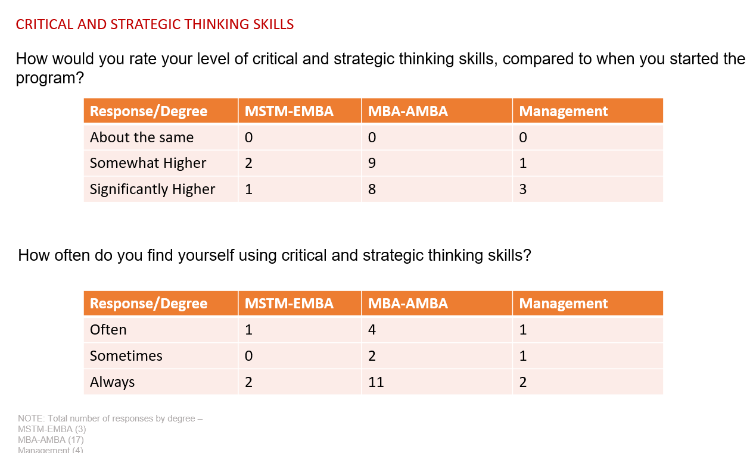

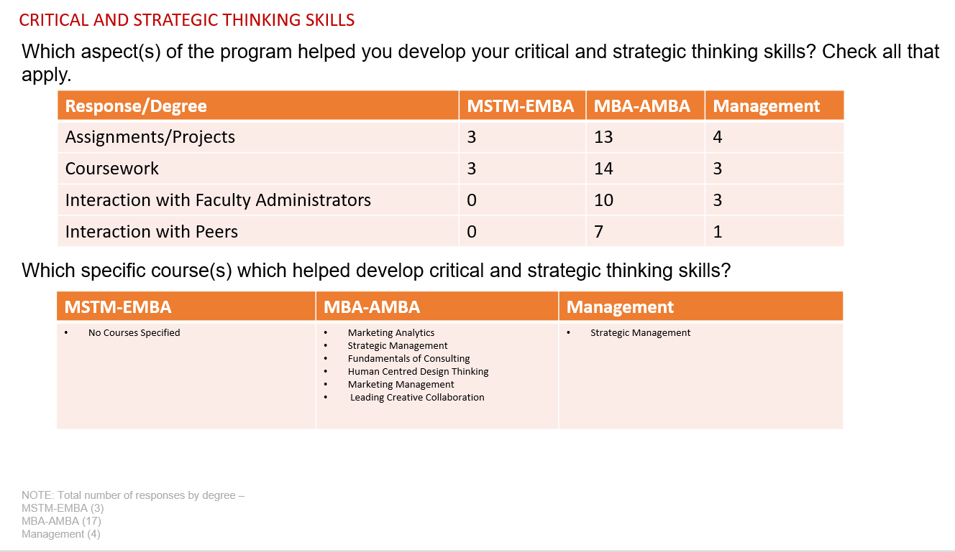
Additional Goal 4: Our students will be able to effectively utilize analytic problem-solving skills.
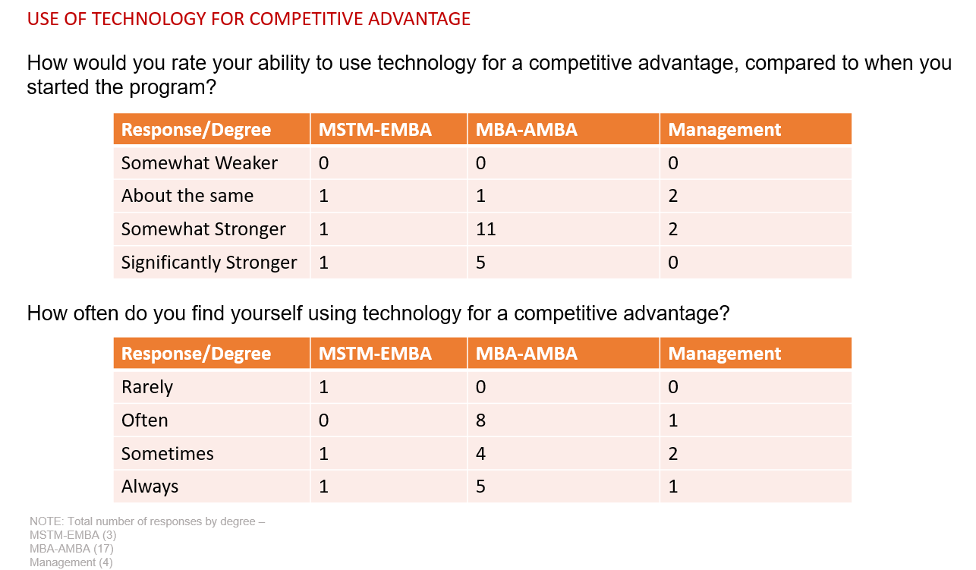
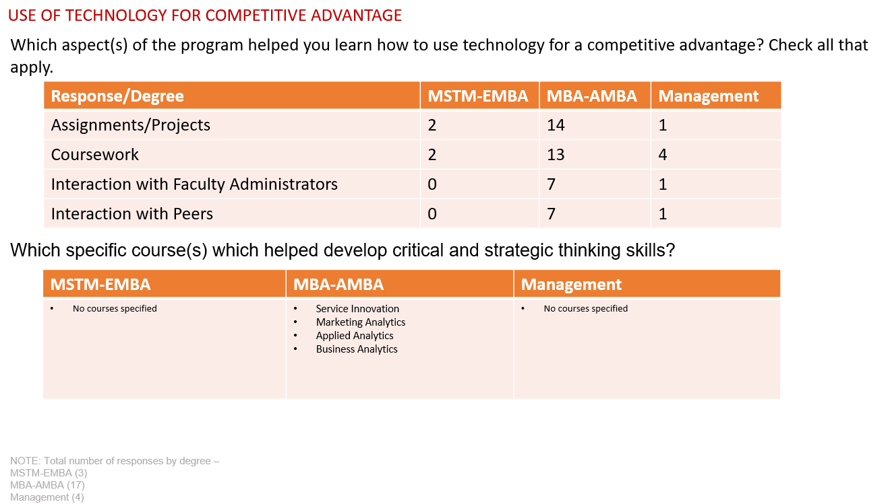

Exit survey conducted in May 2023
Additional Goal 1: Written Communication Skills & Presentation Skills
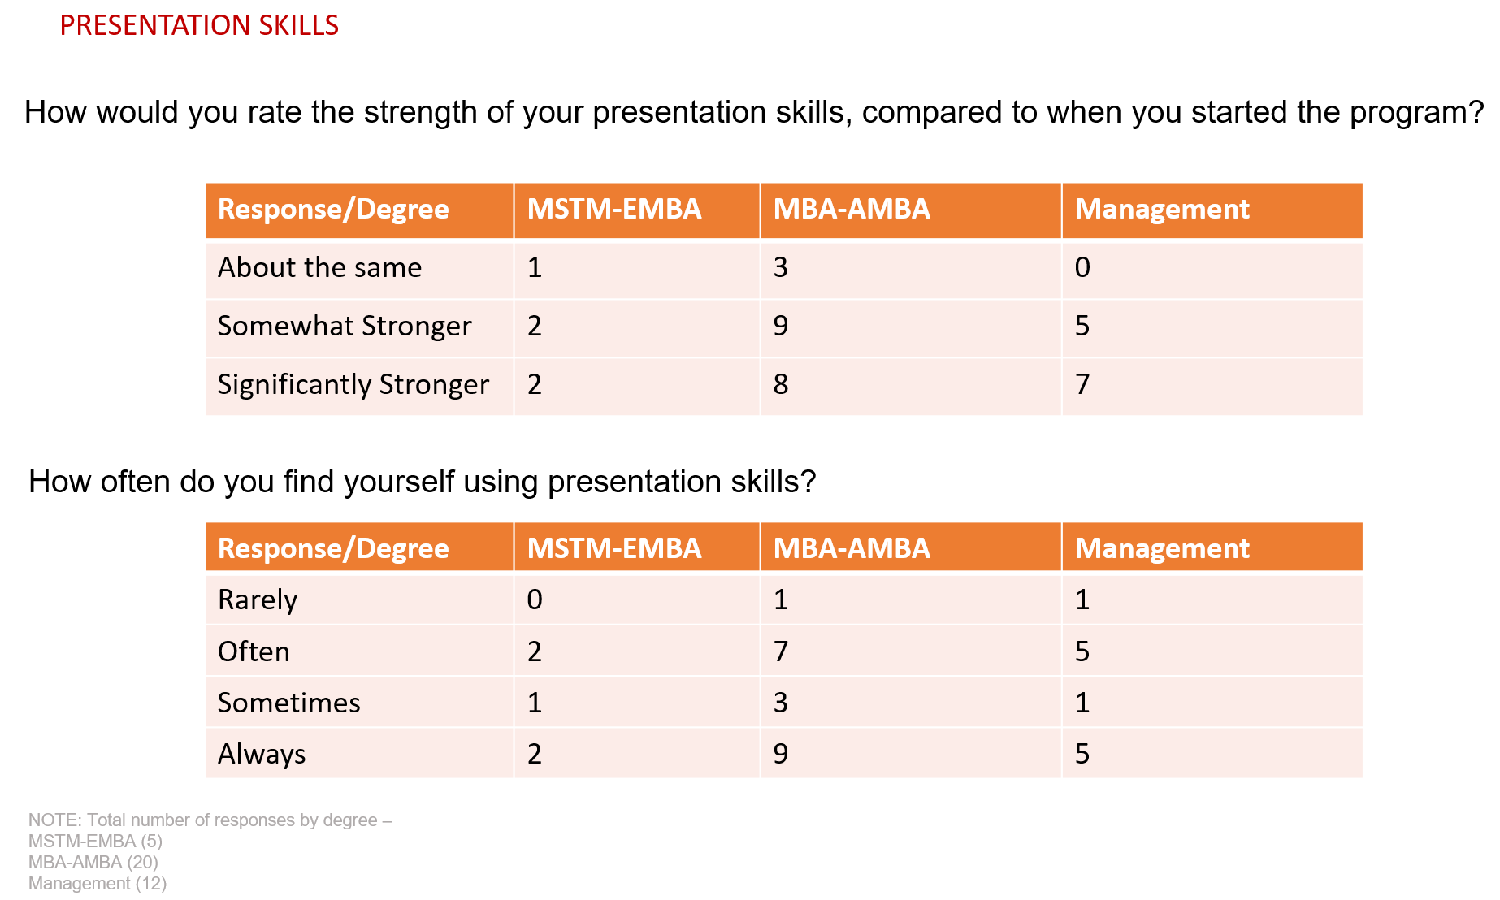
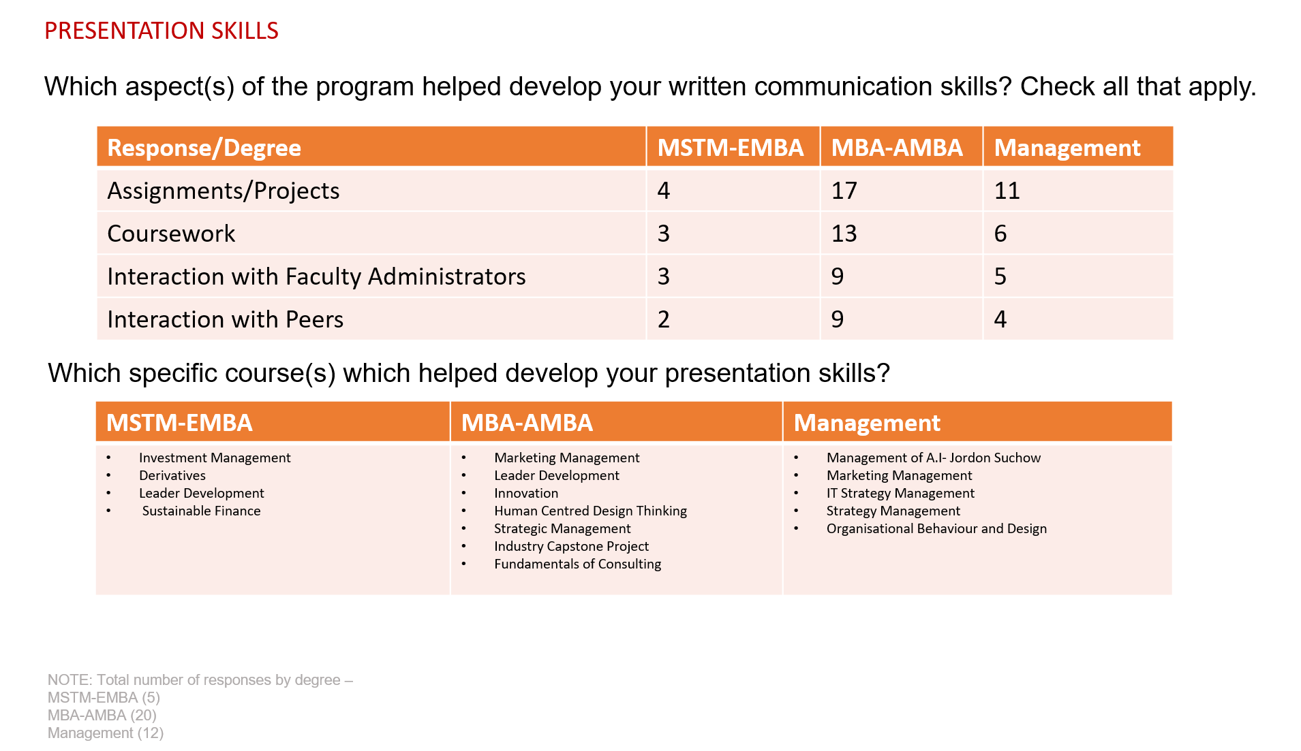
Additional Goal 2: Students can interact effectively in teams.
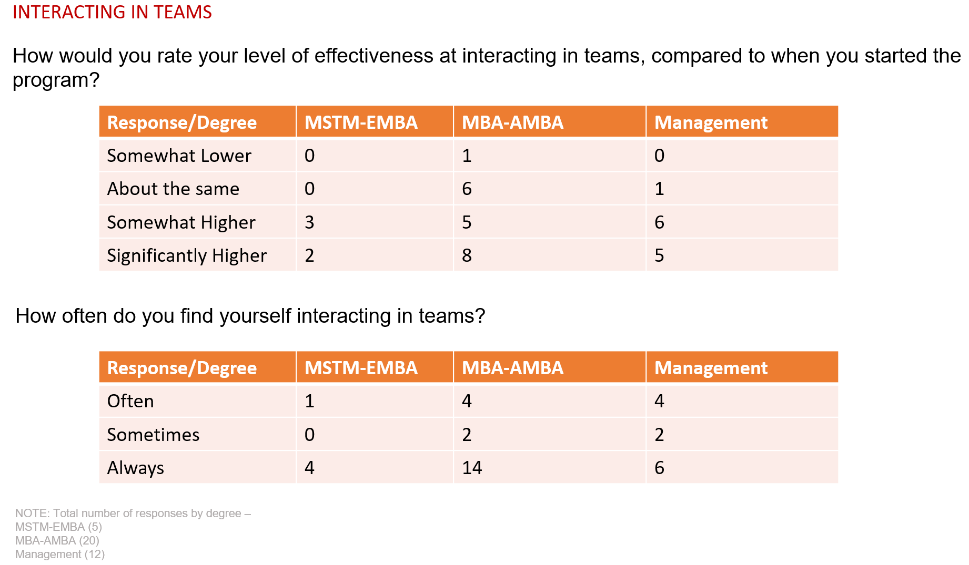
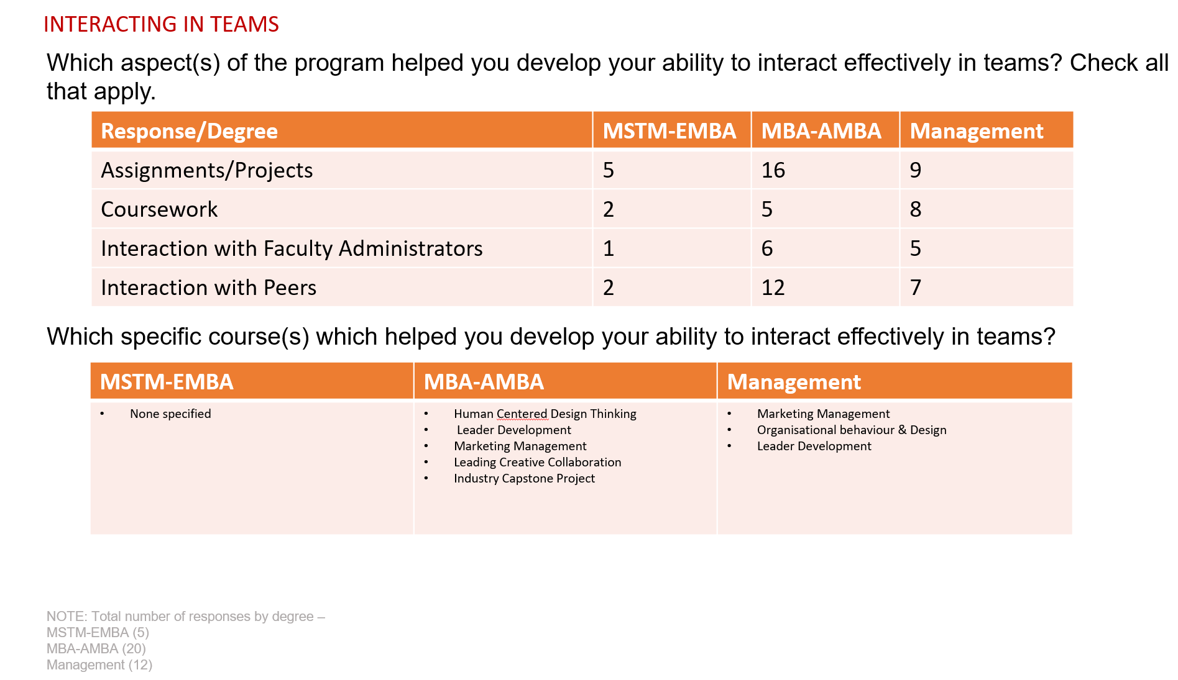
Additional Goal 3: Students will understand how a firm uses technology for competitive advantage in satisfying its business strategy.
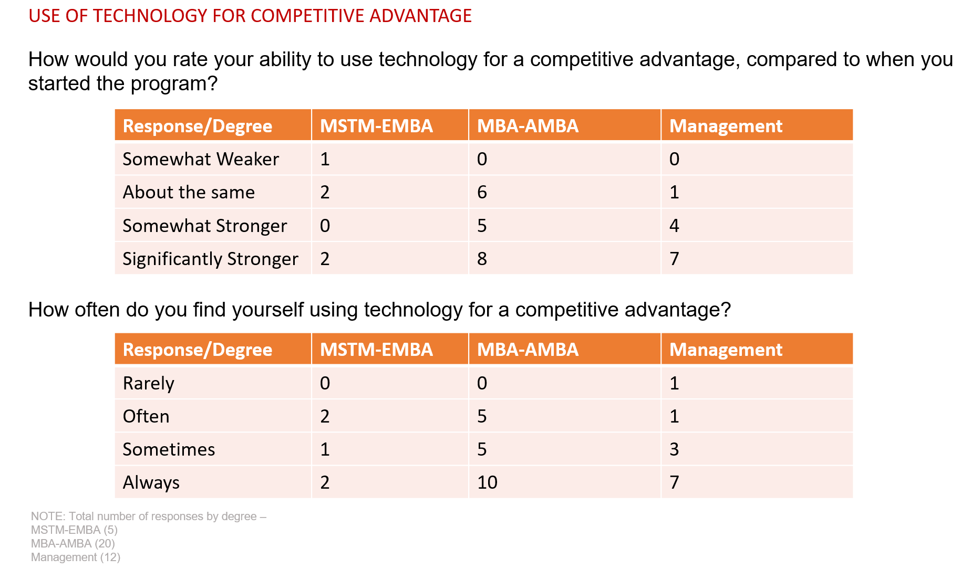
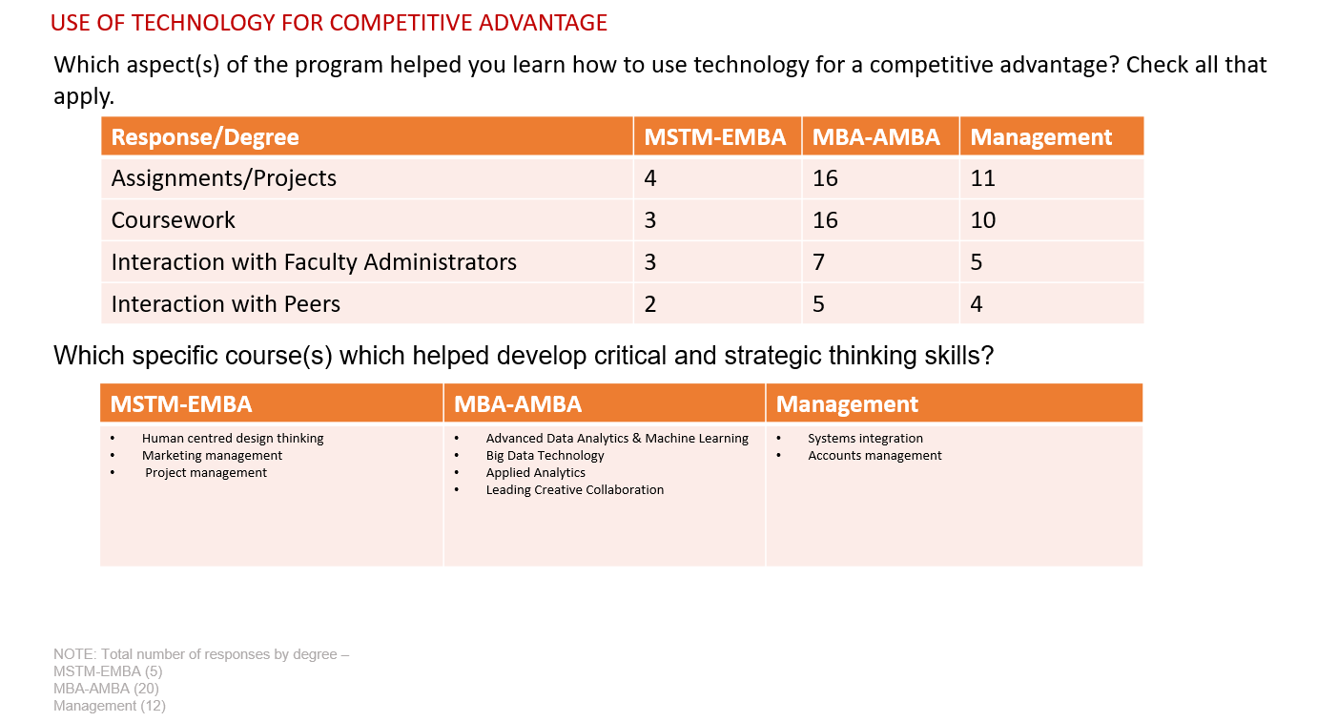

3. CONTINUOUS IMPROVEMENT RECORD

Program: MS in Technology Management (MSTM) and Executive MBA (EMBA)

Goals MSM 1, 2, 3 and 4: Improvement of Competencies Goals
Goal Owner: Brian Rothschild
Where Measured: Graduate exit survey administered in May each year (just before Commencement.)
How Measured: Google Form
Sampling: All MSTM/EMBA students who graduated in May 2024 and May 2023

The MS in Technology Management (MSTM) and Executive MBA (EMBA) degrees recognize that executive-level courses must offer a strong technology perspective to be relevant in a fast-changing world. Our courses in marketing, finance, strategy, and operations emphasize the use of analytical tools that are changing how decisions are made in these disciplines. Faculty teach students to approach problems with entrepreneur-like flexibility and use emerging technologies to become an innovator who brings greater sophistication and efficiency to the enterprise. The cohort format of this program fosters teamwork and collaborative learning.
Via a survey of continuing and graduating students, the majority of graduate management student respondents assessed a significant level of improvement in each of the skills and abilities mentioned above (compared to their skills prior to starting their program). Overall, they expressed valuing: assessments by instructor, utilization of simulations, and incorporation of other interactive and experiential exercises.

