Stevens Institute of Technology
School of Business

AACSB
ASSURANCE OF LEARNING

Master of Science in Technology Management

LEARNING GOAL # 4
Identify, assess, launch, and lead organizational strategic initiatives in a technology-based environment for the creation of new business models (i.e., corporate entrepreneuring) in a large corporation including both sustaining and disruptive businesses.

Responsibility: Peter Koen

May 28, 2022

Table of Contents

1. Introduction: Learning Goal #4……………………………………………...…………3

2. Learning Objectives and Traits (Direct and Indirect)….……………………...………..4

3. Rubrics………………………………………………………………………………….5

4. Assessment Process…………………………………………………………………….7

5. Results of Learning Goal Assessment – Introduction………………………….……….7

6. Results of Assessment: Spring 2021……………………...…………………………….8

7. Outcomes/Close the Loop Process After First Rounds of Assessments………………9

8. Results of Assessment: Spring 2022……………………...………………………….10

9. Outcomes/Close the Loop Process After Second Round of Assessments……………12

1. INTRODUCTION: LEARNING GOAL #4
Identify, assess, launch, and lead organizational strategic initiatives in a technology-based environment for the creation of new business models in a large corporation including both sustaining and disruptive businesses.
This learning goal assessment takes place in course EMT 752: Corporate Entrepreneuring. Other courses are also involved in this assessment exercise: EMT 741 Innovation Management Process, EMT 642: Marketing Management in Technical Organizations, and the final capstone course EMT 798: Integration & Application of Technology.

In EMT 752, students are challenged to propose a corporate entrepreneurship project in their company. They are assessed not only on the content of their proposals but also on whether they succeed in having their proposals implemented (see objective 2 trait 1). A high percentage of these proposals are actually funded. The actual funding rate since the course was started in 2008 are indicated below

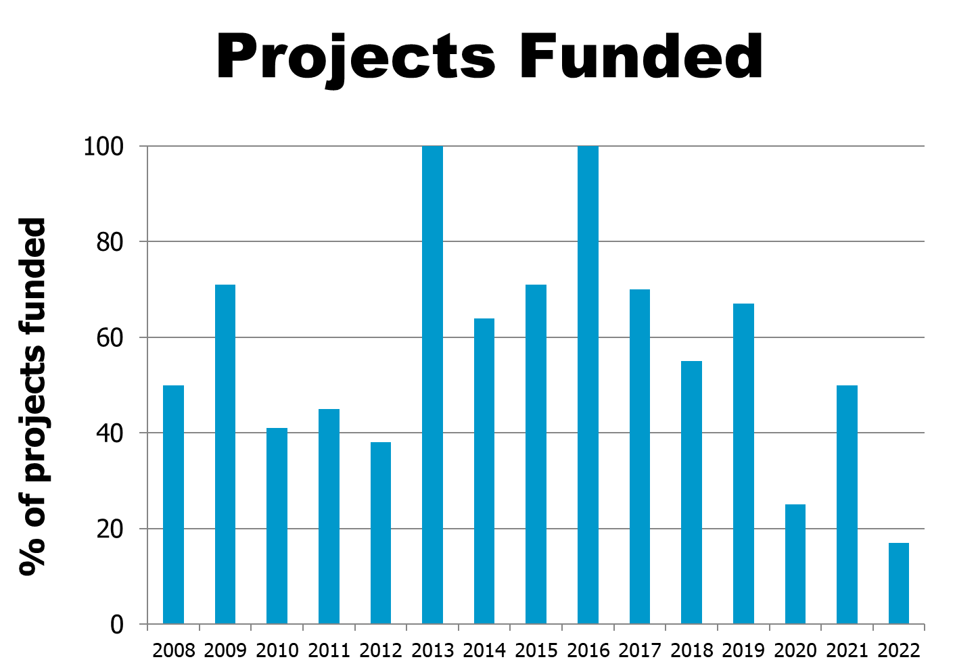

Some funded project examples are provided below.

Due to the confidential nature of many of the projects the companies prefer not to give the actual funding amount. However, it typically ranges from $50,000 to $300,000. A sampling of the projects funded in one of some of my classes, whose brief descriptions are not confidential, are indicated below:

1. This project will address speed to market issue in the telematics segment by improving internal project processes, so that network project managers can launch telematics products faster to their customers and satisfy the marketing executive needs of speed to market. Existing agile processes are not working for the telematics segment due to the delays in gathering accurate customer requirements which results in a final product which is not close to the customer wants. The proposed solution addresses in creating a special architecture team which will work with the marketing team and customers in finalizing the accurate requirements and test processes so that the design and architecture can be finalized, and an accurate product is delivered. This solution results in reduced costs, improves the speed to market and yields customer satisfaction resulting in profit growth.

2. The sales force alignment engine system project will be able to satisfy the unmet customer needs of Roche Canada Sales and Marketing team and Regional Business Managers. The alignment process enables users to view and maintain the alignment of customers (hospitals, pharmacies, federal agencies and professionals) with various postal codes based on geographical locations for the entire product-based sales forces.

3. Building a simple, time-saving and all-digital home staging experience through both Walmart.com and the Walmart App. A user can browse curated styles for a home that encompasses both furniture and décor. In twenty minutes or less a customer can choose which room(s) to stage, the style they’re looking for, the specific pieces of furniture or décor to stage the room(s) and even schedule the delivery date and time. Most importantly, Walmart Home Staging will always have ‘everyday low prices’ on all furniture and décor pieces.
2. LEARNING OBJECTIVES AND TRAITS
Objective 1 (Direct Measurement): | Being able understand the strategy, issues, processes and constraints associated with developing a sustaining and disruptive innovation in a large corporation.
Traits
Trait 1: | Understand how change happens and the importance of social capital associated with new innovations in large corporations.
Trait 2: | Understand of how to simultaneously of develop and implementing both a sustaining and disruptive innovations.
Trait 3: | Understand the ability to develop a business model for a new project.

Objective 2:  (Indirect Measurement) | Be able to develop a business model for a new product or service and understand the associated political and organizational constraints which are associated with gaining social and financial capital.
Traits
Trait 1: | Be able to understand and gain support of the organization for a new product or service.
Trait 2: | Be able to present a compelling business model innovation to a group of executives at the conclusion of the course.

3. RUBRICS

Objective 1: Being able understand the strategy, issues, processes and constraints associated with developing a sustaining and a disruptive innovation in a large corporation.

 | Trait | Poor | Good | Excellent
 | Value | 0 | 5 | 10
Trait 1: | Understand how change happens and the importance of social capital associated with new innovations in large corporations. | Achieving a critical mass of less than 14 out of 20 change agents in a Harvard Business change management simulation. | Being able to achieve a critical mass of between 15 and 17 change agents in a Harvard Business change management simulation. | Being able to achieve a critical mass of 18 out of 20 change agents in a Harvard Business change management simulation. .
Trait 2: | Understand of how to simultaneously of developing and implementing both a sustaining and disruptive innovation strategy. | Being unable to produce a profit while simultaneously supporting a sustaining and disruptive innovation as indicated in a Harvard Business school simulation. | Being able to produce a profit while simultaneously supporting a sustaining and disruptive innovation as indicated in a Harvard Business school simulation. | Being able to produce a significant profit while simultaneously supporting a sustaining and disruptive innovation as indicated in a Harvard Business school simulation.
Trait 3: | Understand the ability to develop a business model for a new project. | Be unable to discuss and explain the business model and MVP for their project. | Being able to discuss and explain most parts of the business model as well as the MVP (minimum viable prototype) for the new project. | Being able to superbly discuss and explain each portion of the business model as well as the MVP (minimum viable prototype) for their new project.

Objective 2: . Be able to develop a business model for a new product or service and understand the associated political and organizational constraints which are associated with gaining social and financial capital.

 | Trait | Poor | Good | Excellent
 | Value | 0 | 5 | 10
Trait 1: | Be able to understand and gain support of the organization for a new product or service | Be unable to gain political support for the project or service in a company | Being able to gain support from an executive champion for their project – but not able to gain funding. | Be able to gain funding from the corporation for their project.
Trait 2: | Be able to present a compelling business model innovation to a group of executives at the conclusion of the course. | Provides a poorly prepared story for their business model innovation. | Provides an acceptable story for their business model innovation. | Provides an outstanding, clear and compelling story for their business model innovation.

4. ASSESSMENT PROCESS

Where & When Measured? | How Measured?
The first objective, which is a direct measurement, will be measured every semester. | The first two traits will be determined by a Harvard Business simulation on change and managing disruptive innovation. The third trait will be determined on a grade the students receive on the business model for their project by the faculty.
The second objective, which is an indirect measurement, will also be measured every semester. | The first trait will be measured by an executive champion, required for every project, in the students’ company. The second trait will be measured by executives who are external to the company and evaluate the project as part of the last class.

5. RESULTS OF LEARNING GOAL ASSESSMENT - INTRODUCTION
The results of the direct and indirect goal assessments are carried out as indicated below.
Explanation
Each learning goal has several learning objectives and performance on each objective is measured using a rubric that in turn contains several desired “traits”. Students are scored individually on each trait.
The grading sheets for each student are used to develop a summary results sheet for each learning goal objective. A selection of these summaries is included below.
The first table in the Summary Results Sheet for a learning objective and trait gives the counts of students falling in each of the three categories:
- Does not meet expectations
- Meets expectations
- Exceeds expectations
The right-hand column in the table is used to record the average score of the students on each trait. This table provides an indication of the relative performance of students on each trait.
The second table on each sheet provides the counts of students who fall in each of the above three categories for the overall learning objective.
The person doing the assessment provides explanatory comments and recommendations on the bottom of the Results Summary Sheet. The recommendations to improve content or pedagogy changes for the next time the course is given.

6. RESULTS OF ASSESSMENT Spring 2021
LEARNING GOAL #: 4. Identify, assess, launch, and lead organizational strategic initiatives in a technology-based environment for the creation of new business models in a large corporation including both sustaining and disruptive businesses.

ASSESSMENT DATE: February 2022
NO. OF STUDENTS TESTED:

LEARNING OBJECTIVE # 1: Being able understand the strategy, issues, processes and constraints associated with developing a sustaining and a disruptive innovation in a large corporation.

 | Number of Students
Learning Goal Traits (Assessor Peter Koen) | Not Meet Expectations | Meet Expectations | Exceed Expectations | Average Grade
1. Understand how change happens and the importance of social capital associated with new innovations in large corporations. | 4 | 0 | 6 | 6.0
2. Understand of how to simultaneously of developing and implementing both a sustaining and disruptive innovation strategy. | 4 | 3 | 3 | 4.5
3. Understand the ability to develop a business model for a new project. |  |  | 10 | 10
Average Grade (Maximum of 10) |  |  |  | 6.8

 | Not meet expectations | Meet Expectations | Exceed Expectations
Total Students by Category  (Based on Average score across all traits) | 2 | 6 | 2
Students meeting or exceeding expectations |  | 80%
Criterion: Does not meet expectations: 0 – 14; Meets: 15 - 25; Exceeds: 26 - 30

COMMENTS: The criteria for the rubrics were made based on a very difficult simulation performance – an independent grade. So, the results are not surprising.

REMEDIAL ACTION: Spend more time in the 2022 class on discussing the fundamentals associated with the simulation prior to the students doing them.

LEARNING OBJECTIVE # 2: Being able to develop a business model for a new product or service and understand the associated political and organizational constraints which are associated with gaining social and financial capital.

 | Number of Students
Learning Goal Traits (Trait 1 to be assessed by corporate champion in students’ company, trait 2 to be assessed by external executives grading the final assignment) | Not Meet Expectations | Meet Expectations | Exceed Expectations | Average Grade
1. Be able to understand and gain support of the organization for a new product or service |  | 6 | 4 | 7.0
2. Be able to present a compelling business model innovation to a group of executives at the conclusion of the course. | 2 | 2 | 6 | 7.0
Average grade (maximum of 10) |  |  |  | 7.0

 | Not meet expectations | Meet Expectations | Exceed Expectations
Total Students by Category  (Based on Average score across all traits) | 1 | 7 | 2
Students meet or exceed expectations |  |  | 90%
Criterion: Does not meet expectations: 0 –9; Meets: 10 - 15; Exceeds: 16 - 20

COMMENTS: Two students failed to provide a compelling business model innovation to a group of executives. This is a high independent criterion.

REMEDIAL ACTIONS: Continue to work with students on how to develop and present and compelling business case.

7. OUTCOMES/CLOSING THE LOOP MSTM FOR LEARNING GOAL # 4 AFTER ROUNDS OF ASSESSMENT
Objectives | Objective 1: Being able understand the strategy, issues, processes and constraints associated with developing a sustaining and a disruptive innovation in a large corporation.  Objective 2: Be able to develop a business model for a new product or service and understand the associated political and organizational constraints which are associated with gaining social and financial capital.
When Assessed: | February 2022
Remedial Action | Objective 1: Spend more time in the 2022 class on discussing the fundamentals associated with the simulation prior to the students doing them. Objective 2: Continue to work with students on how to develop and present and compelling business case.

8. RESULTS OF ASSESSMENT Spring 2022
LEARNING GOAL #: 4. Identify, assess, launch, and lead organizational strategic initiatives in a technology-based environment for the creation of new business models in a large corporation including both sustaining and disruptive businesses.

ASSESSMENT DATE: May 2022
NO. OF STUDENTS TESTED: 6

LEARNING OBJECTIVE # 1: Being able understand the strategy, issues, processes and constraints associated with developing a sustaining and a disruptive innovation in a large corporation.

 | Number of Students
Learning Goal Traits (Assessor Peter Koen) | Not Meet Expectations | Meet Expectations | Exceed Expectations | Average Grade
1. Understand how change happens and the importance of social capital associated with new innovations in large corporations. |  |  | 6 | 10.0
2. Understand of how to simultaneously of developing and implementing both a sustaining and disruptive innovation strategy. | 1 | 3 | 2 | 4.2
3. Understand the ability to develop a business model for a new project. |  |  | 6 | 10.0
Average Grade (Maximum of 10) |  |  |  | 8.1

 | Not meet expectations | Meet Expectations | Exceed Expectations
Total Students by Category  (Based on Average score across all traits) | 0 | 4 | 2
Students meeting or exceeding expectations |  | 100%
Criterion: Does not meet expectations: 0 – 14; Meets: 15 - 25; Exceeds: 26 - 30

COMMENTS: The criteria for the rubrics were made based on a very difficult simulation performance – an independent grade. So, the results are not surprising. Students grasped the concepts related to change management and overall were very interested in this topic. Hence the performance on the simulation. Regarding developing and implementing both a sustaining and disruptive innovation strategy, the simulation assessment utilized was conducted at the most difficult level. This level included both an assessment of the technologies as well as continuous financial analyses.

REMEDIAL ACTION: Spend more time in the 2022 class on discussing the fundamentals associated with the simulation prior to the students doing them. Students were very eager to spend more time on change management. It is suggested to expand the module on this topic as many students found this to be an important tool in their respective organizations. Regarding developing and implementing a sustaining and disruptive innovation strategy, perhaps it might be helpful to the students to start one step down regarding difficulty level working up to including financial analyses.

LEARNING OBJECTIVE # 2: Being able to develop a business model for a new product or service and understand the associated political and organizational constraints which are associated with gaining social and financial capital.

 | Number of Students
Learning Goal Traits (Trait 1 to be assessed by corporate champion in students’ company, trait 2 to be assessed by external executives grading the final assignment) | Not Meet Expectations | Meet Expectations | Exceed Expectations | Average Grade
1. Be able to understand and gain support of the organization for a new product or service | 0 | 5 | 1 | 5.8
2. Be able to present a compelling business model innovation to a group of executives at the conclusion of the course. | 0 | 3 | 3 | 5.0
Average grade (maximum of 10) |  |  |  | 5.4

 | Not meet expectations | Meet Expectations | Exceed Expectations
Total Students by Category  (Based on Average score across all traits) |  | 5 | 1
Students meet or exceed expectations |  |  | 100%
Criterion: Does not meet expectations: 0 –9; Meets: 10 - 15; Exceeds: 16 - 20

COMMENTS: Two students failed to provide a compelling business model innovation to a group of executives. The students who failed to meet expectations for the most part did not do a thorough analysis of existing solutions of which the executive reviewers were familiar. The business model innovation process was generally followed, however further customer discovery was needed on several projects. This is a high independent criterion.

REMEDIAL ACTIONS: Continue to work with students on how to develop and present a compelling business case. Further explain and work with the students regarding the pitfalls of inadequate customer discovery and an inadequate analysis of the competitive landscape.

9. OUTCOMES/CLOSING THE LOOP MSTM FOR LEARNING GOAL # 4 AFTER ROUNDS OF ASSESSMENT
Objectives | Objective 1: Being able understand the strategy, issues, processes and constraints associated with developing a sustaining and a disruptive innovation in a large corporation.  Objective 2: Be able to develop a business model for a new product or service and understand the associated political and organizational constraints which are associated with gaining social and financial capital.
When Assessed: | May 2022
Remedial Action | Objective 1: Spend more time in the 2022 class on discussing the fundamentals associated with the simulation prior to the students doing them. Objective 2: Continue to work with students on how to develop and present and compelling business case.

