Stevens Institute of Technology

School of Business

**AACSB  
ASSURANCE OF LEARNING PLAN**

**Graduate Management Program:**

**Master of Business Administration**

**(MBA)**

**INDIRECT GOALS**

**MBA 5: Written Communication Skills & Presentation Skills**

**MBA 6: Interacting in Teams**

**MBA - 7. Critical and Strategic Thinking Skills**

**MBA- 8: Use of Technology for Competitive Advantage**

**Responsibility: Brian Rothschild**

June 24, 2024

**Table of Contents**

1. Indirect Measurements for Competency Goals MBA 5, MBA 6, MBA 7, MBA 8…......3-5

2. Results – Graduate Exit Survey

May 2024 ……………………………………………………………………..…6-10

May 2023 …………………………………………………………………..……11-15

3. Continuous Improvement Record …………………………………………………….…15

4. CPT Intern Evaluations

Summer 2023……………………………………………………………….…...16-23

Spring 2023…………………………………………………………….………..24-31

Fall 2022 ……………………………………………………………….….…….32-40

1. Indirect Measurements

We will conduct a survey of recent graduates to obtain their perspective on the extent to which their studies helped them develop in relation to all four MBA Competency goals. For each goal, we will pose three questions focusing on graduates’ knowledge and skills efficacy/confidence and two open-ended questions will ask them to describe the ways in which what they learned are relevant to their current work and activities. We anticipate surveying 10-20 graduates. We expect the questions asked to evolve over time.

|  |  |
| --- | --- |
| Competency Goal | Indirect Measurements |
| MBA - 5.  Students can communicate effectively in written and oral presentations. | We will conduct a survey of recent graduates to obtain their perspective on the extent to which their studies helped them develop in relation to all four MBA Competency goals. For each goal, we will pose three questions focusing on graduates’ knowledge and skills efficacy/confidence and two open ended questions will ask them to describe the ways in which what they learned are relevant to their current work and activities. We anticipate surveying 10-20 graduates. We expect the questions asked to evolve over time. |
| MBA - 6. Students can interact effectively in teams. | Indirect measurements will be taken at periodic intervals. Depending on the measurement chosen, a diagnostic tool will be selected for analysis. One possibility is interviews. The interview will be structured, with representative team members. The structured interview will gather information about the key competencies. The responses will be subjected to a content analysis. Another option for the future is employer/supervisor feedback about the students’ teamwork skills.  Additionally, we will conduct a survey of recent graduates to obtain their perspective on the extent to which their studies helped them develop in relation to all four MBA Competency goals. For each goal, we will pose three questions focusing on graduates’ knowledge and skills efficacy/confidence and two open ended questions will ask them to describe the ways in which what they learned are relevant to their current work and activities. We anticipate surveying 10-20 graduates. We expect the questions asked to evolve over time. |
| MBA - 7. Our students will be able to develop and analyze descriptive, predictive, and prescriptive models using software tools to aid in decision-making | We will conduct a survey of recent graduates to obtain their perspective on the extent to which their studies helped them develop in relation to all four MBA Competency goals. For each goal, we will pose three questions focusing on graduates’ knowledge and skills efficacy/confidence and two open ended questions will ask them to describe the ways in which what they learned are relevant to their current work and activities. We anticipate surveying 10-20 graduates. We expect the questions asked to evolve over time. |
| MBA - 8. Our students will be able to effectively utilize analytic problem-solving skills. | Indirect measures will only be used in case of the score associated of a rubric in the mid-term evaluations falls below 50 percentage points  The indirect measures will be based on a Survey conducted to the employers of recent graduates to get their feedback over the analytical skills acquired in the Competency goal #4. There will be two types of questions: First, questions related to confidence in graduates/employees analytical skills and their capacity of combining different analysis/points of view. Second, questions to describe the ways in which such analytical skills have had a significant impact on the organization. It is important to highlight that these questions will be asked in comparison to graduates/ employees coming from peer institutions  Possible questions to cover both objectives are listed below (We anticipate surveying 10-20 graduates. We expect the questions asked to evolve over time)  Efficacy (1-5 Likert scale agree /disagree). In comparison to graduates / employees from peer institutions.   * This program studies provided employees with opportunities to develop significant analytical skills in group as well as being part of a team of analysts. * Because of these studies and assignments of the program, the analytical skills developed, whether individually or within a group, have improved significantly. * The feedback received from the program is very updated and other candidate of the same institution should be considered     Relevance + Application (open ended questions)   * Focus on a situation that required the analytical skills developed to solve a problem (answers in comparison to graduates / employees from peer institutions)   + What was the situation   + What are the first taken by the graduate/employee?   + Did s/he understand the problem?   + What the outcome was?   + Was it important to analyze the problem as a team? * When it comes to analytical skills at an *individual level*, the graduate / employee would have benefited from more opportunities to learn about or do the following (answers in comparison to graduates / employees from peer institutions) * When it comes to analytical skills at a *group level*, the graduate / employee would have benefited from more opportunities to learn about or do the following (answers in comparison to graduates / employees from peer institutions).   Additionally, we will conduct a survey of recent graduates to obtain their perspective on the extent to which their studies helped them develop in relation to all four MBA Competency goals. For each goal, we will pose three questions focusing on graduates’ knowledge and skills efficacy/confidence and two open ended questions will ask them to describe the ways in which what they learned are relevant to their current work and activities. We anticipate surveying 10-20 graduates. We expect the questions asked to evolve over time. |

**2. RESULTS – GRADUATE EXIT SURVEY**

The survey conducted in May 2024

**Additional Goal 5: Written Communication Skills & Presentation Skills**

**Additional Goal 6: Students can interact effectively in teams.**

**Additional Goal 7: Our students will be able to develop and analyze descriptive, predictive, and prescriptive models using software tools to aid in decision-making.**

**Additional Goal 8: Our students will be able to effectively utilize analytic problem-solving skills.**

**The survey conducted in May 2023**

**Additional Goal 5: Written Communication Skills & Presentation Skills**



**Additional Goal 6: Students can interact effectively in teams.**

**Additional Goal 7: Our students will be able to develop and analyze descriptive, predictive, and prescriptive models using software tools to aid in decision-making.**

**Additional Goal 8: Our students will be able to effectively utilize analytic problem-solving skills.**

**3. CONTINUOUS IMPROVEMENT RECORD-**

**Program:** Master of Business Administration (MBA)

**Goals MBA 5, 6, 7 & 8: Improvement of Competencies Goals**

**Goal Owner:** Brian Rothschild

**Where Measured:** Graduate exit survey administered in May each year (just before Commencement.)

**How Measured:** Google Form

Sampling: All MBA students who graduated in May 2024 and May 2023.

Our MBA courses feature applied exercises that prepare students to serve as leaders who are capable of making fast, data-supported decisions. MBA coursework emphasizes collaboration through group projects and presentations and develops student creativity and critical thinking skills through the incorporation of new analytical tools and the latest research insights.

Via a survey of graduating students, the majority of graduate management student respondents assessed, reported that their MBA experience somewhat or significantly improved their abilities (compared to their skills prior to starting their program) in relation to the program goals and the competencies associated with them. Experiential aspects (assignments, projects, simulations, collaborative learning) of their education were reported to be most instrumental to students' skill development, although they also valued interaction with faculty and peers.

**Summer 2023 CPT Intern Evaluation**

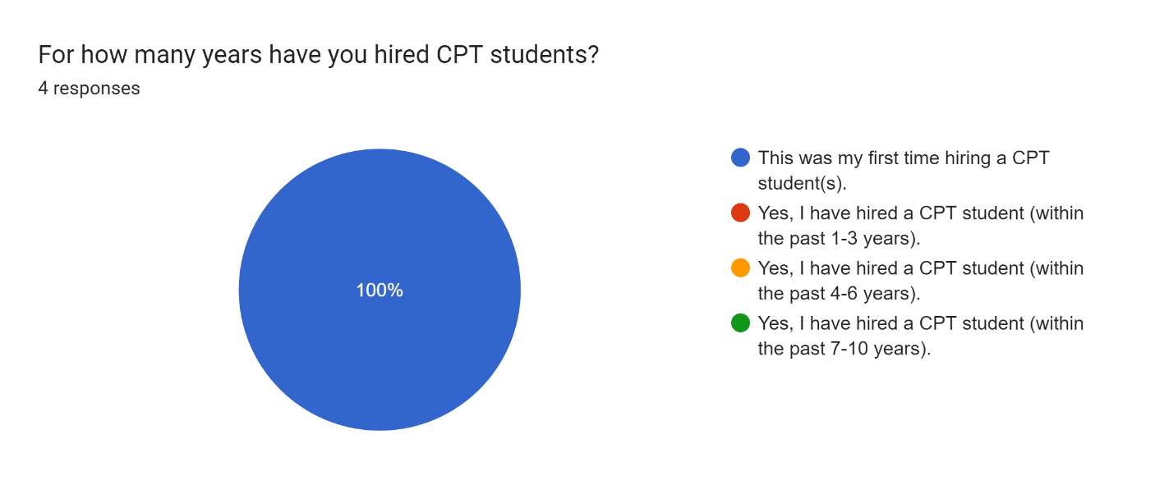

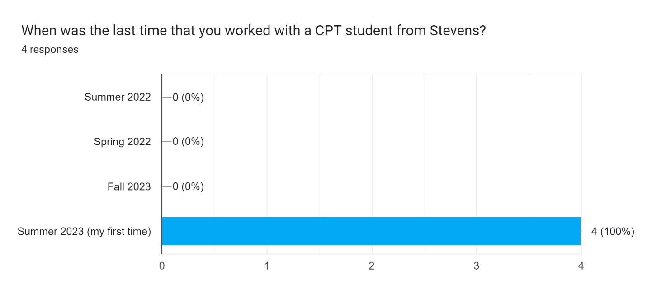

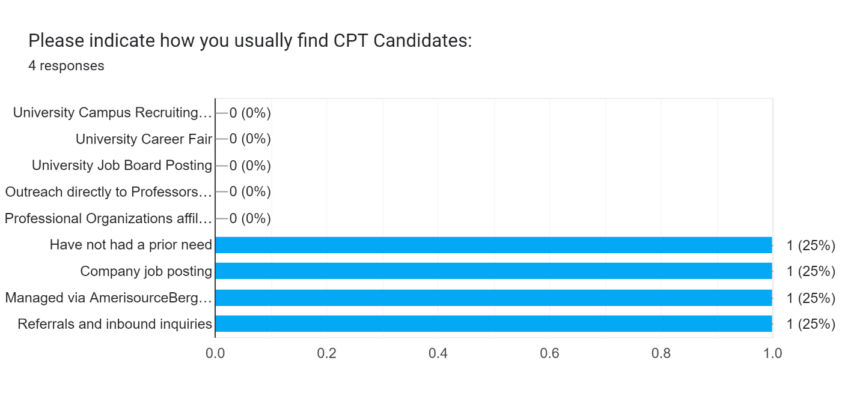

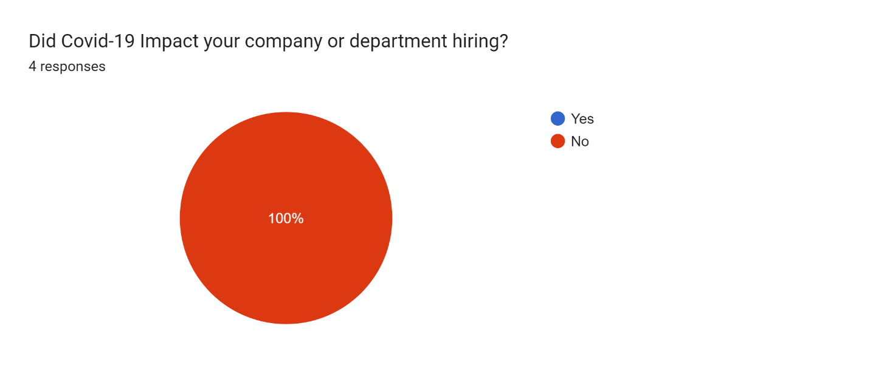

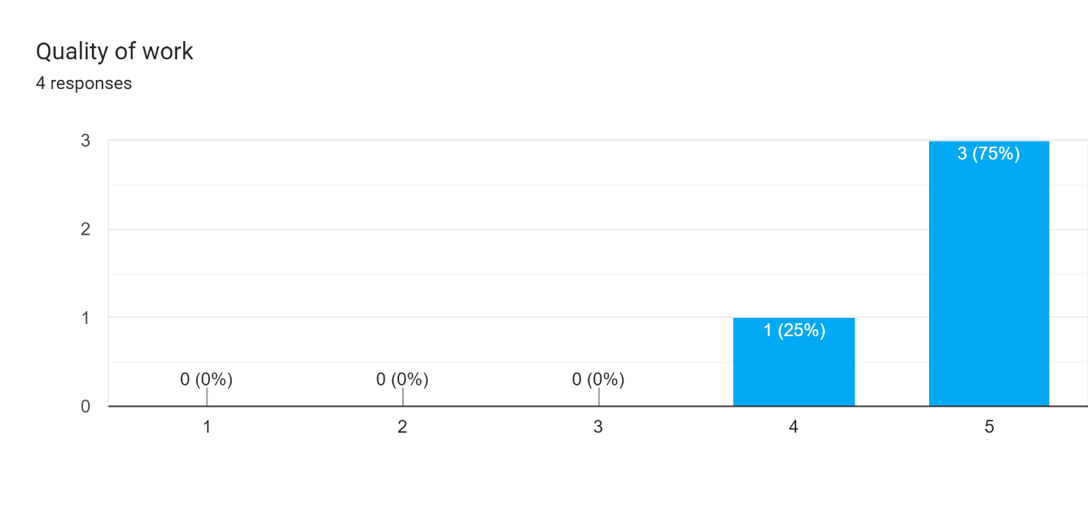

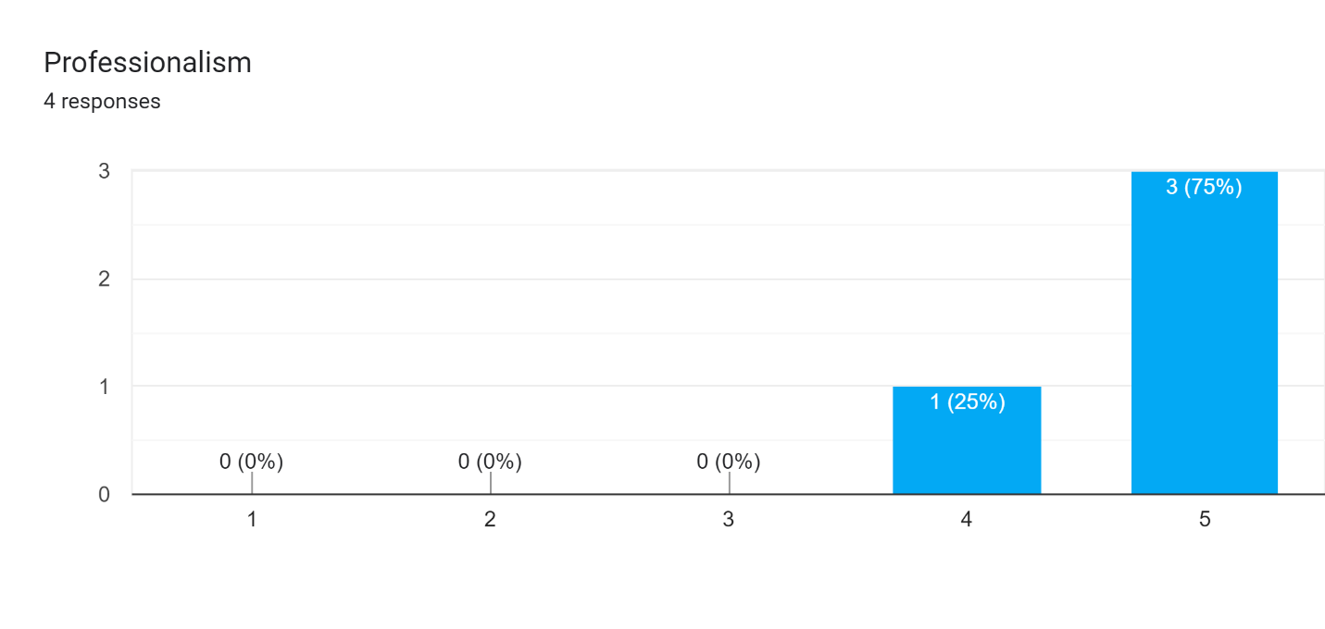

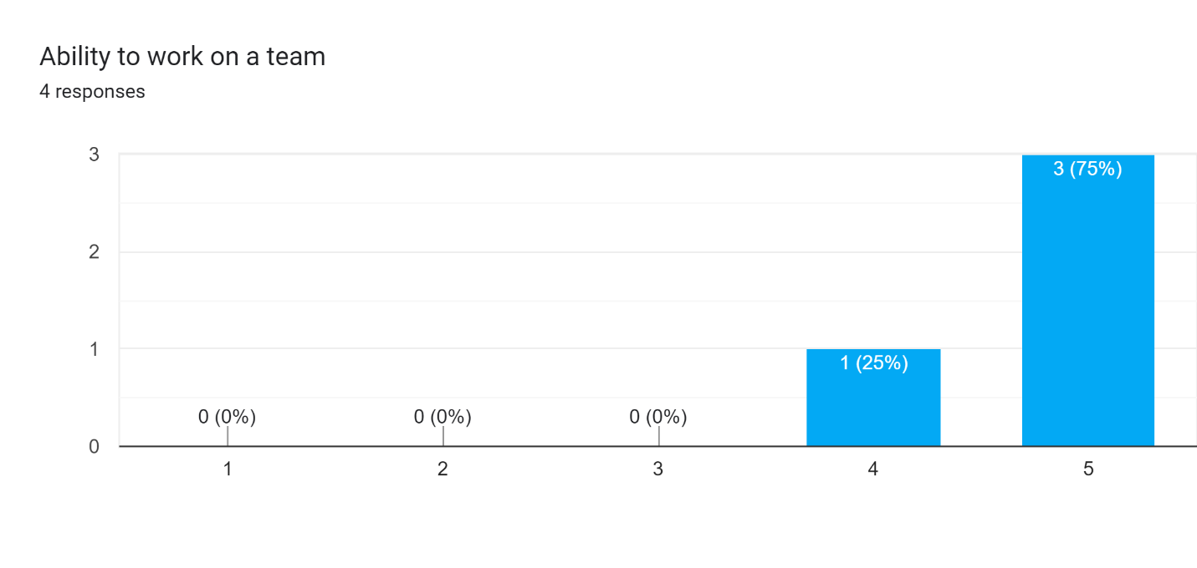

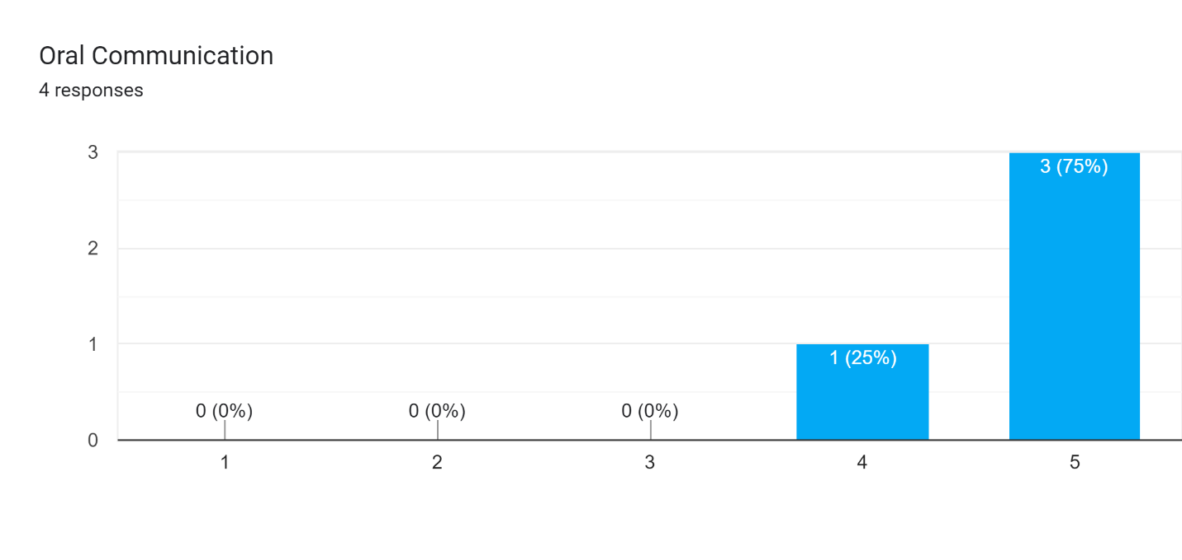

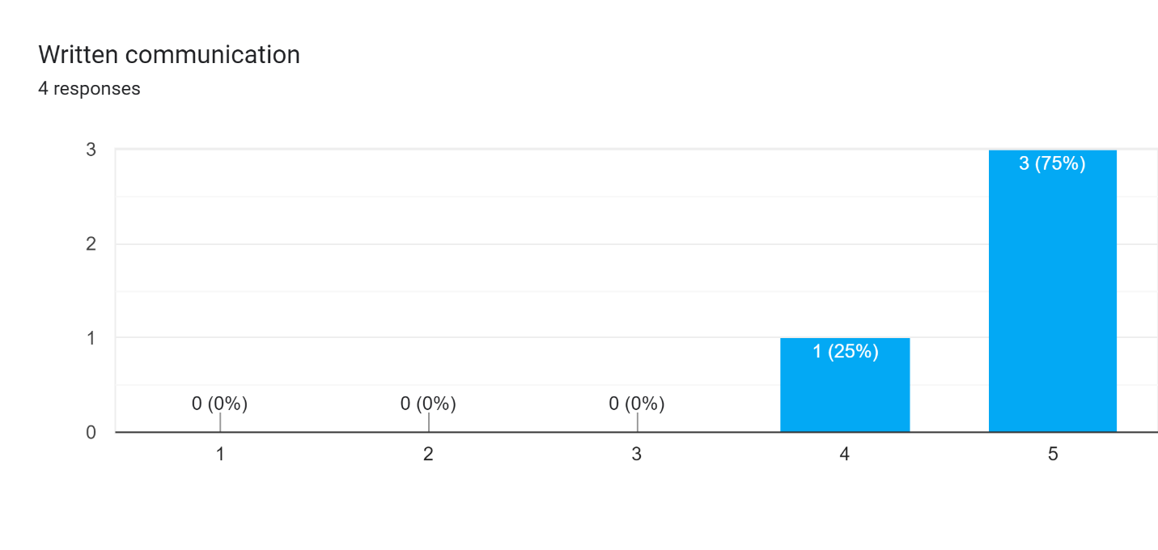

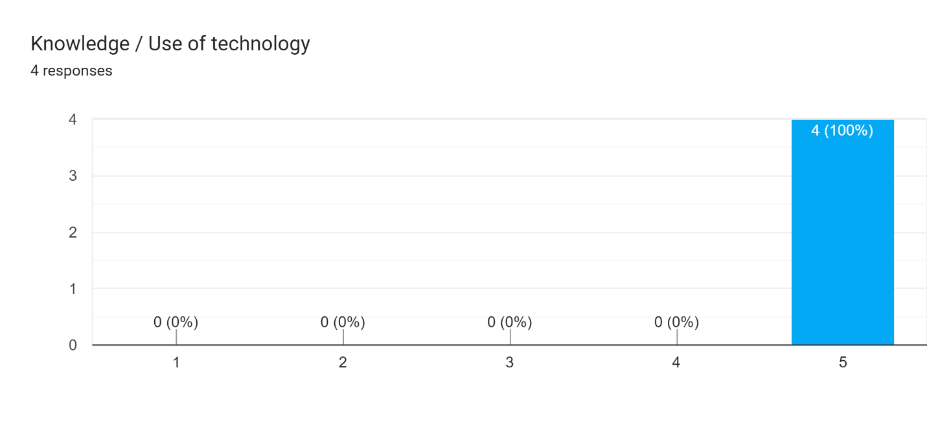

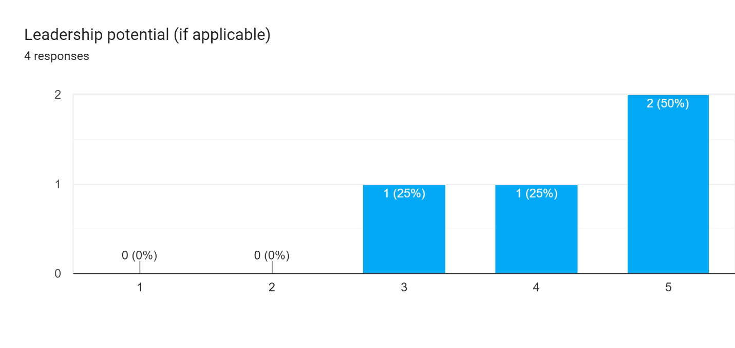

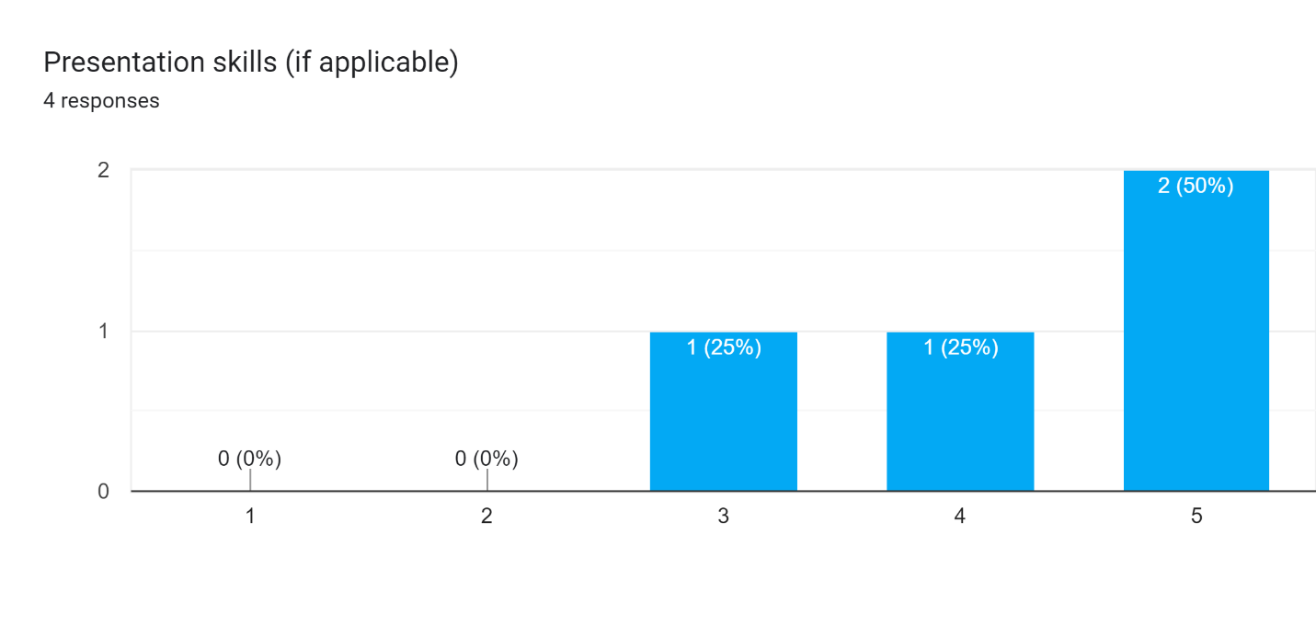

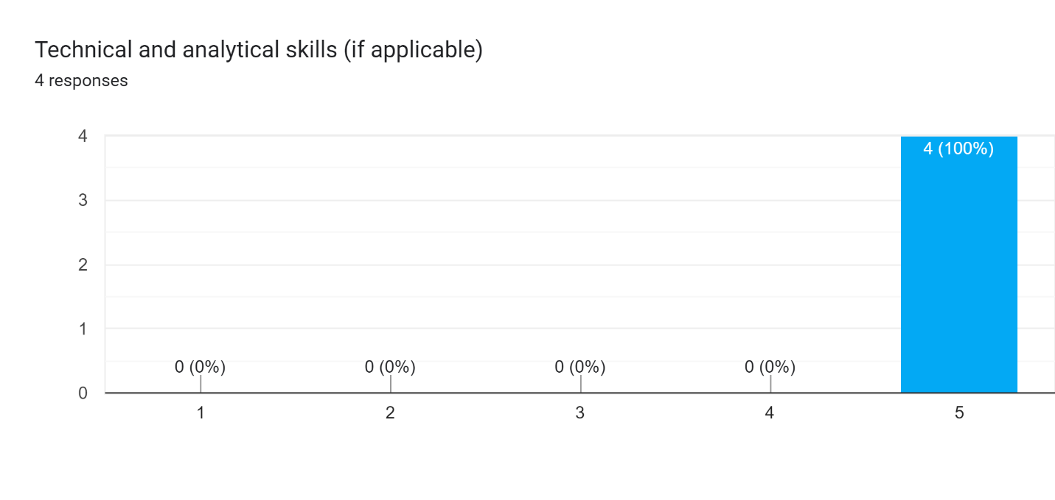

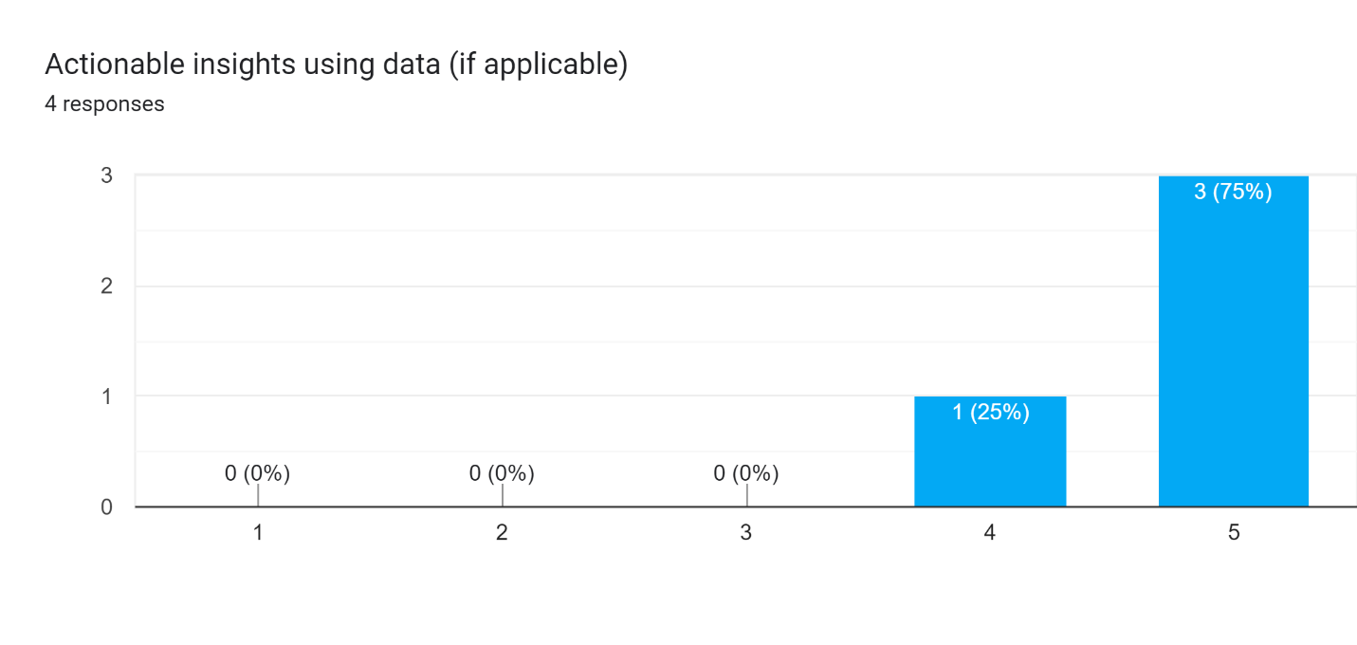

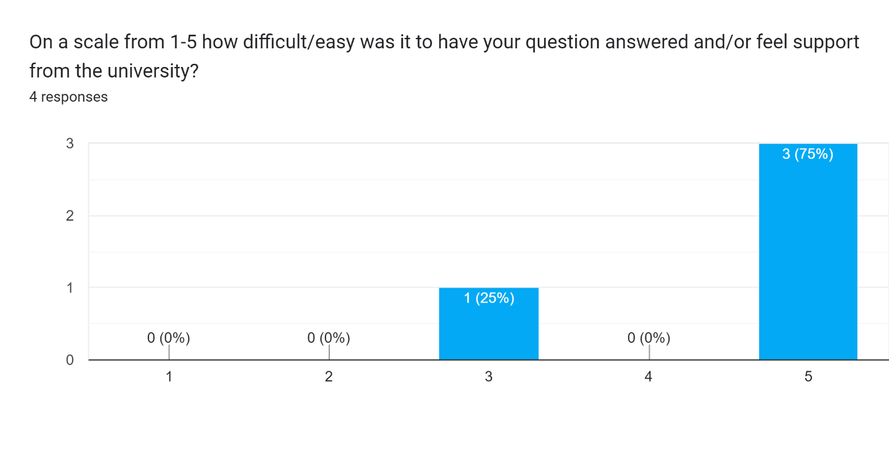

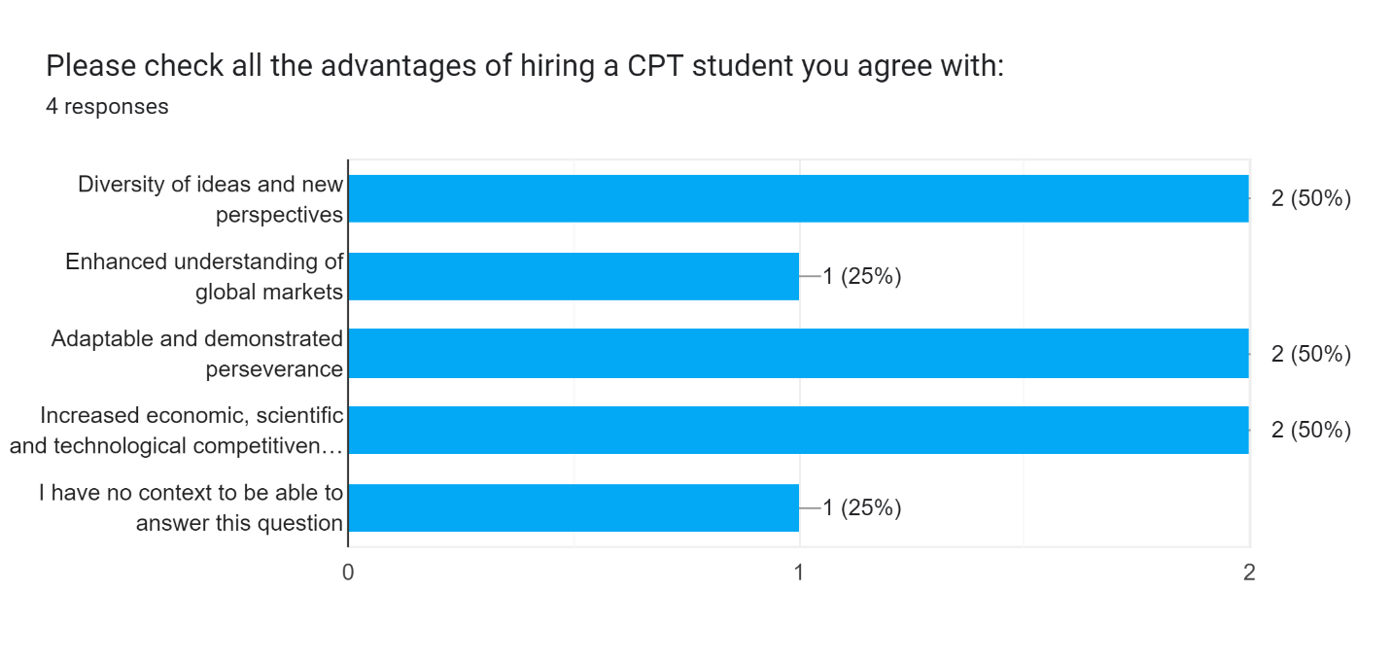

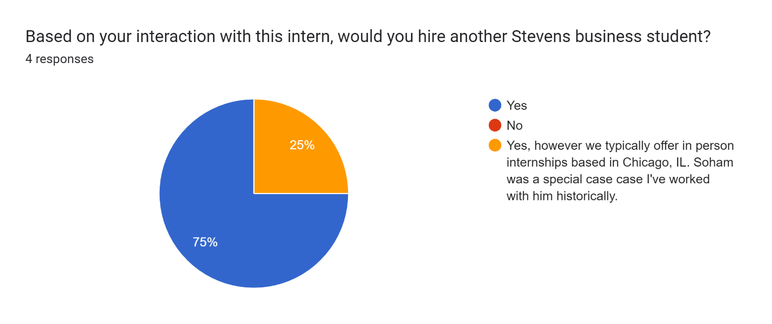

**Spring 2023: CPT Intern Evaluation**

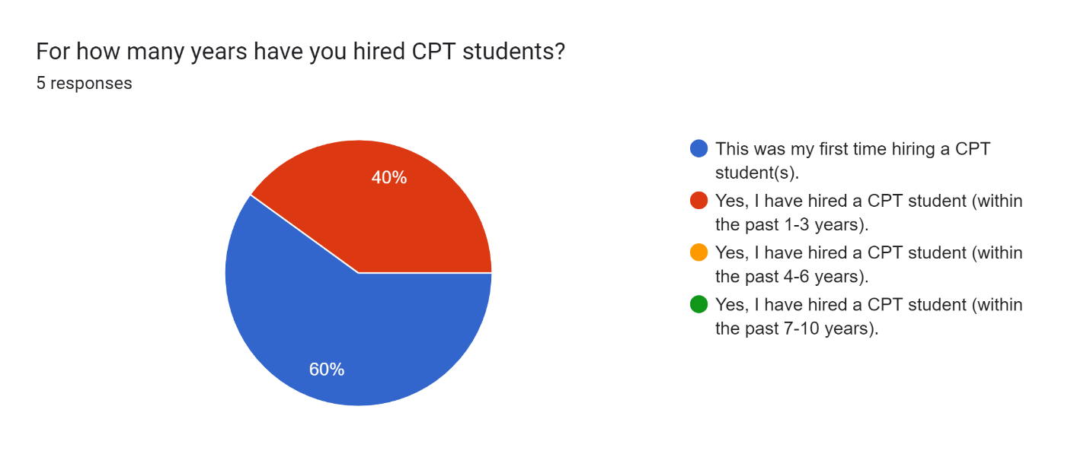

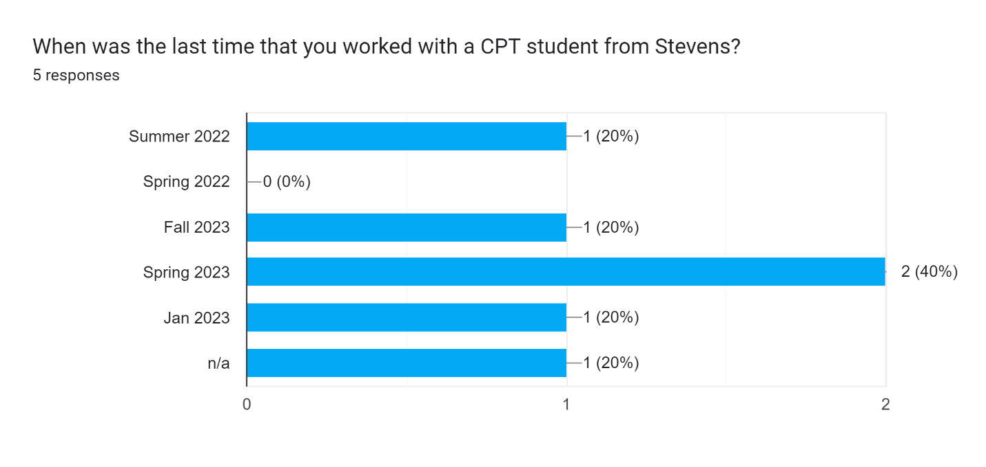

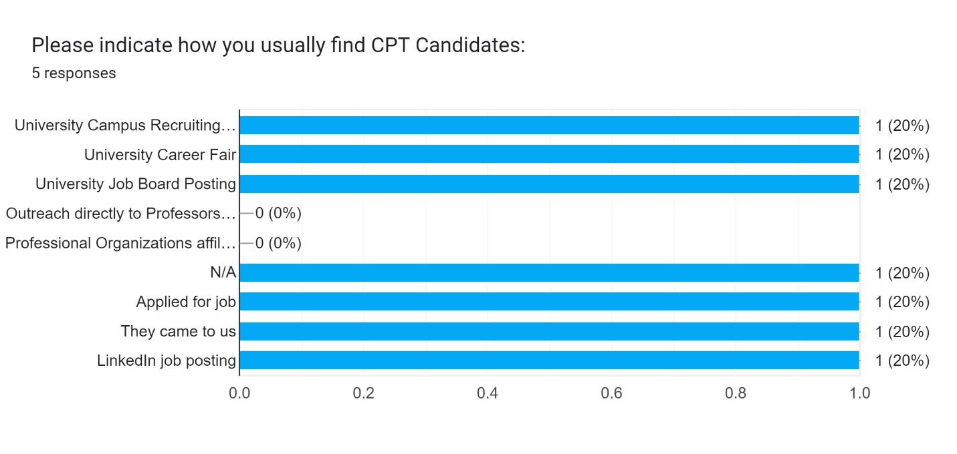

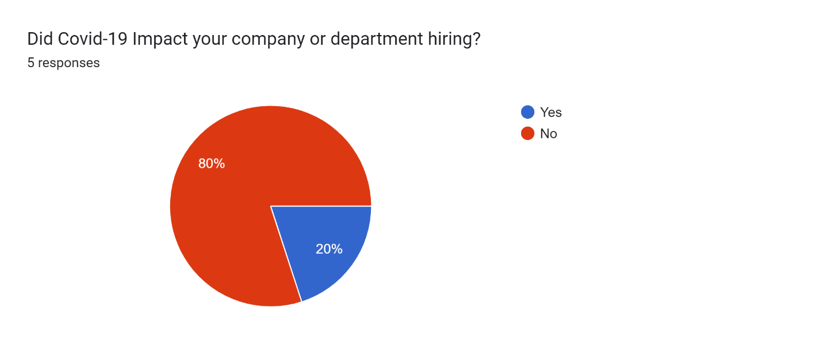

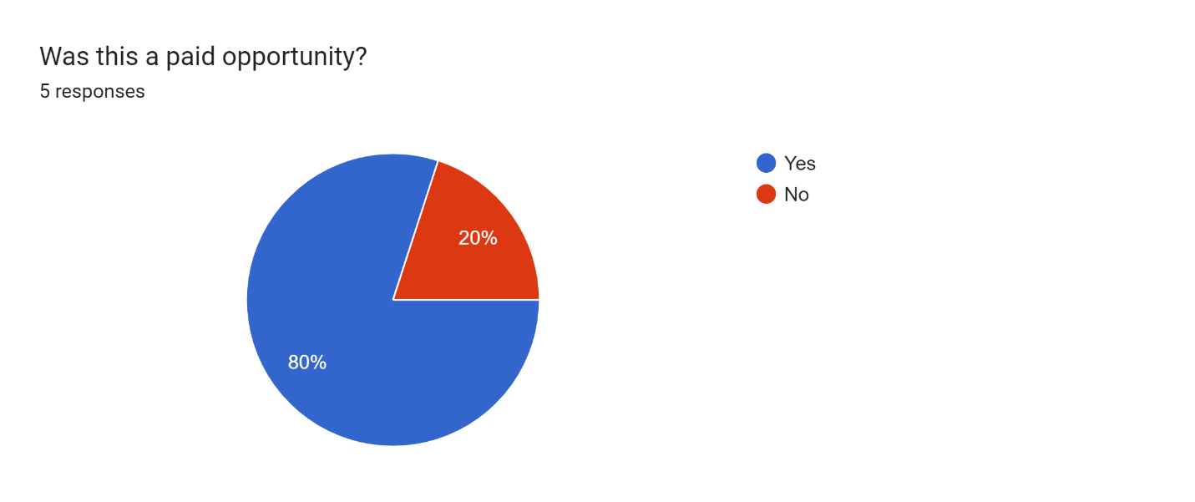

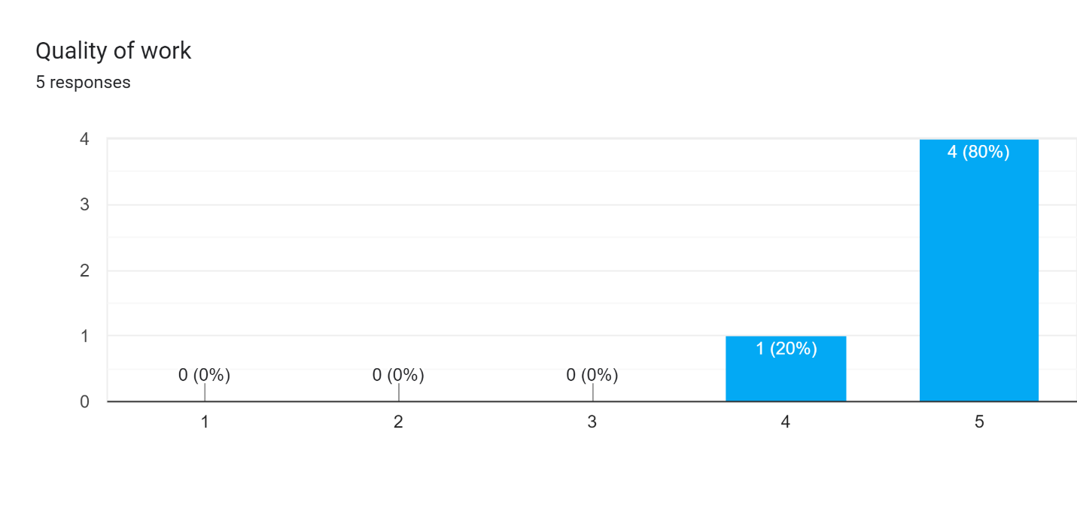

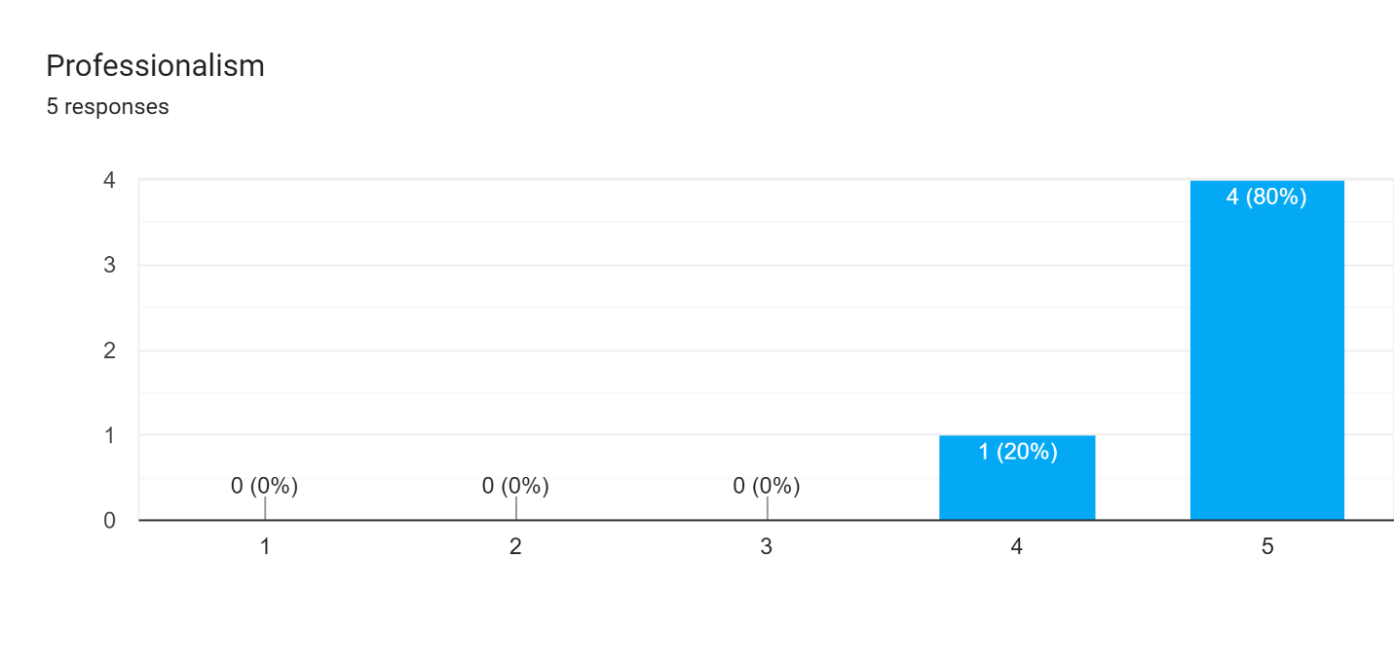

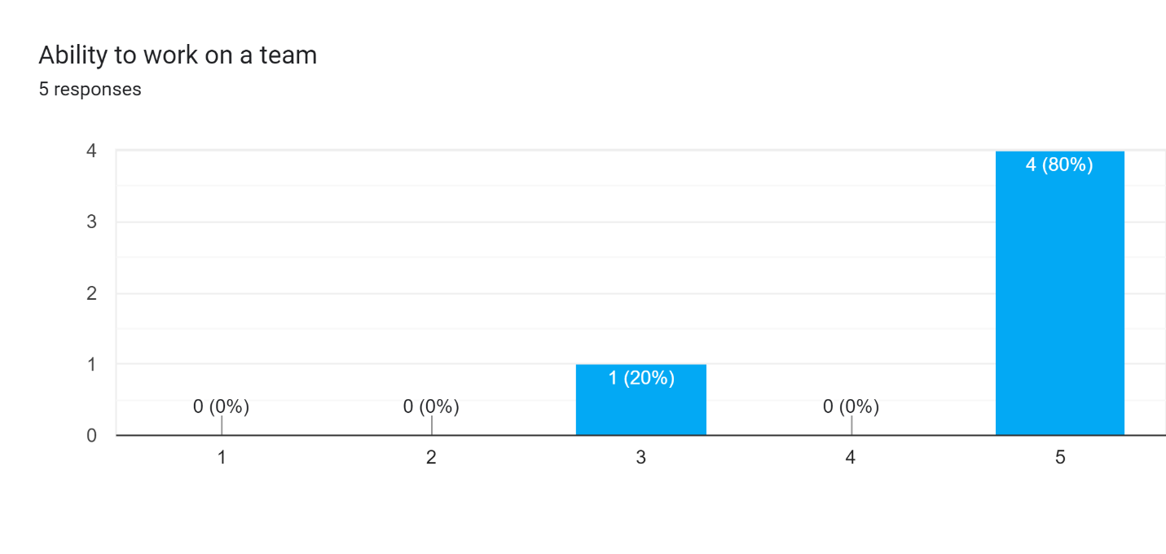

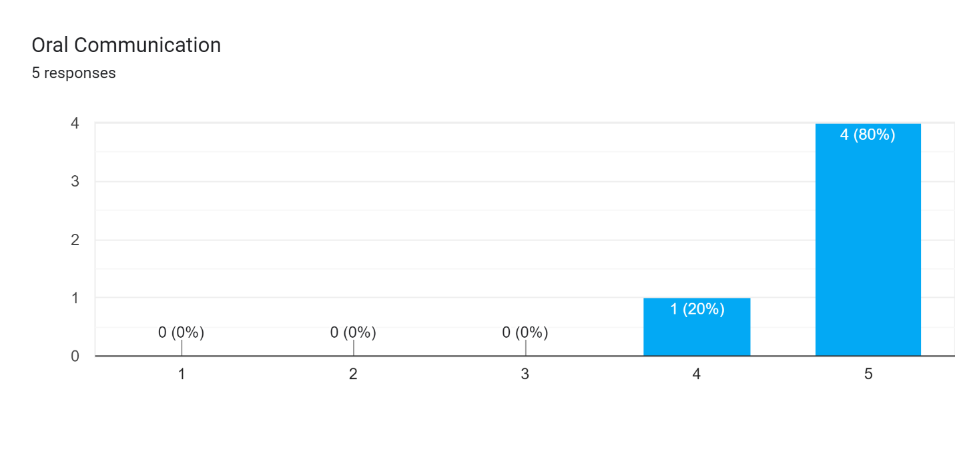

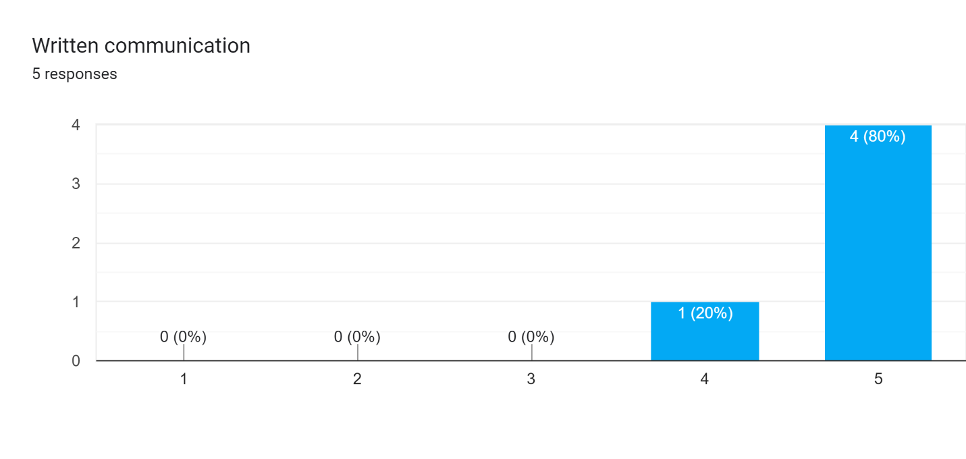

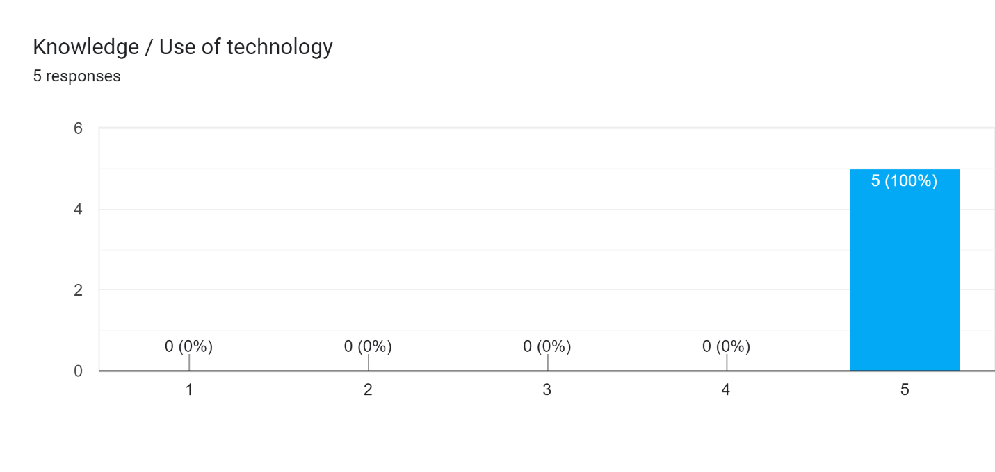

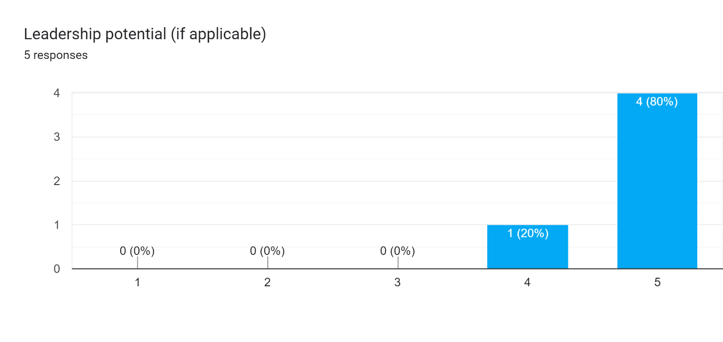

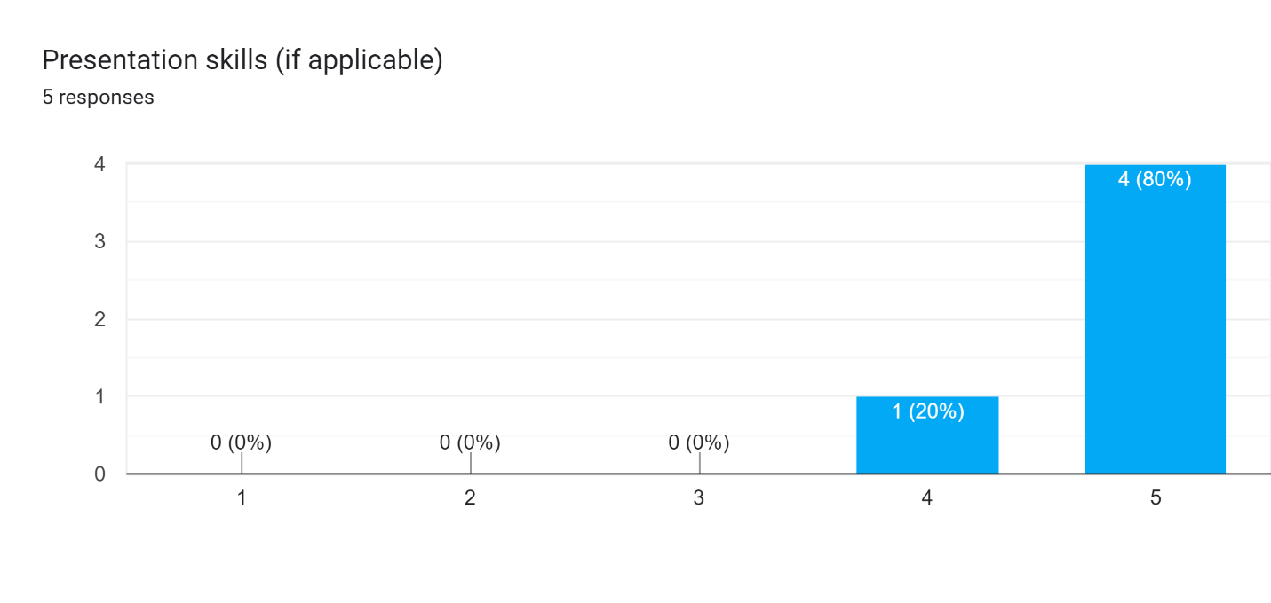

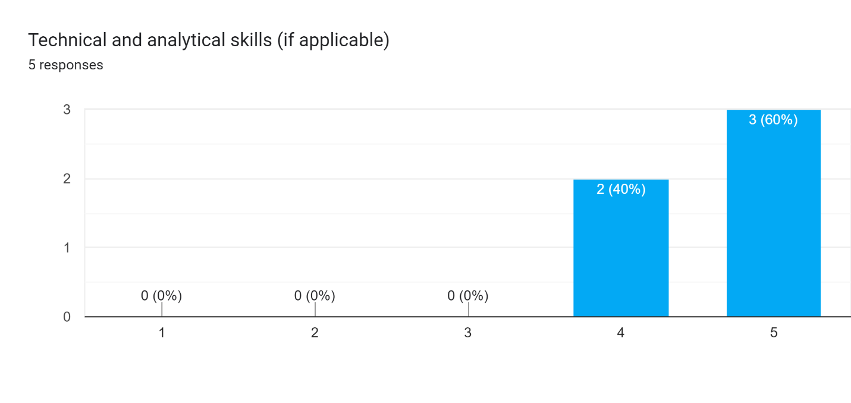

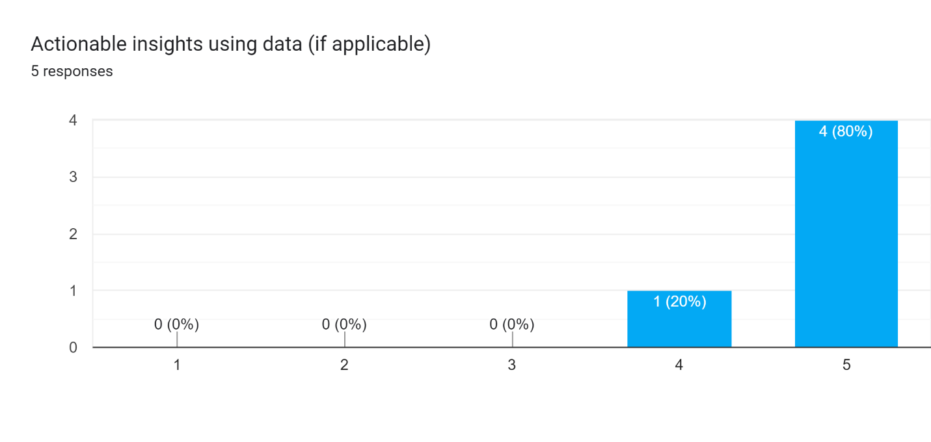

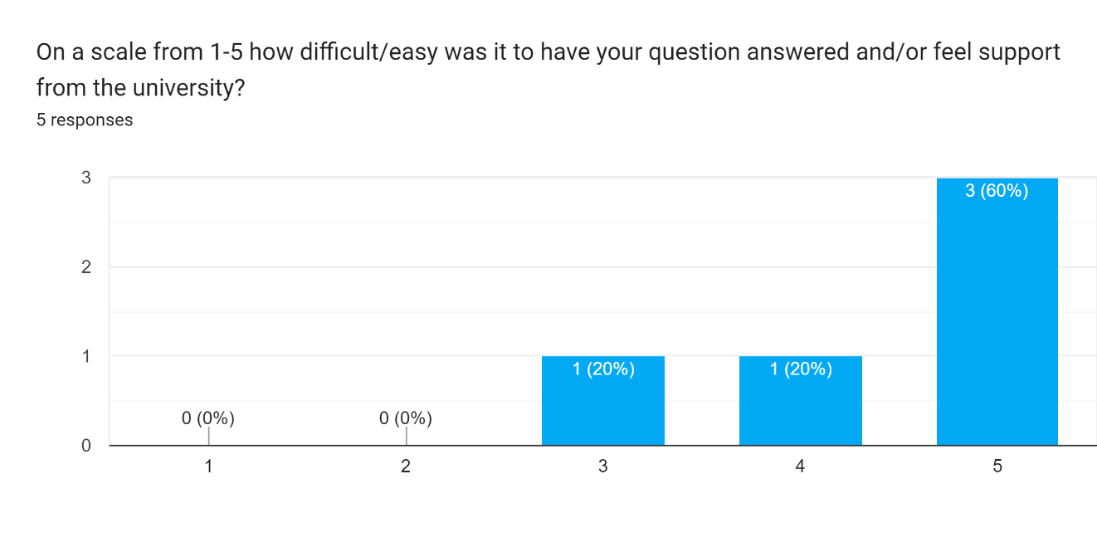

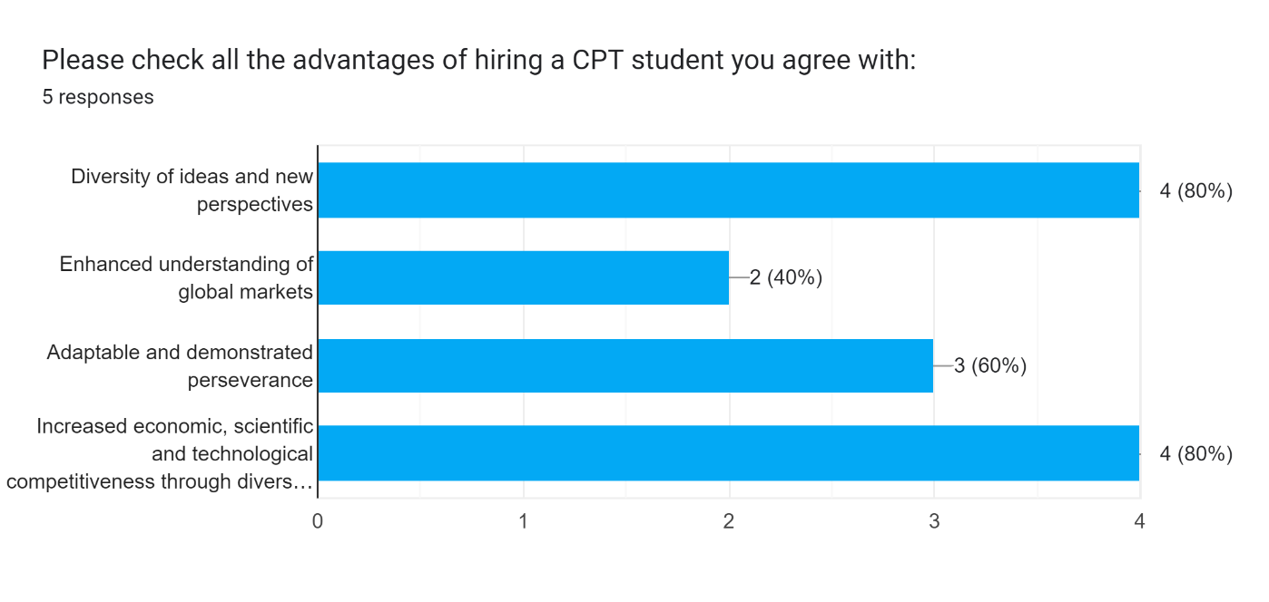

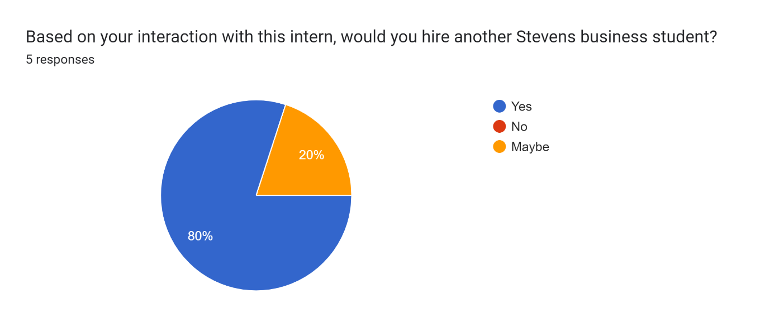

**Fall 2022: CPT Intern Evaluation**

