Stevens Institute of Technology

School of Business

**AACSB  
ASSURANCE OF LEARNING PLAN**

**Graduate Management Program:**

**Master of Science in Management**

**(MSM)**

**INDIRECT GOALS**

**MSM - 1: Written Communication Skills & Presentation Skills**

**MSM 2: Interacting in Teams**

**MSM- 3: Use of Technology for Competitive Advantage**

**MSM- 4: Critical and Strategic Thinking Skills**

**Responsibility: Brian Rothschild**

June 24, 2024

**Table of Contents**

1. Indirect Measurements for Competency Goals MSM 1, MSM 2, MSM 3, MSM 4…......3-5

2. Results- Graduate Exit Survey

May 2024 ………………………………………………………………………6-10

May 2023 ………………………………………………………………………11-15

3. Continous Improvement Record………………………………………………………….15

4. CPT Intern Evaluations

Summer 2023……………………………………………………………….…...17-24

Spring 2023…………………………………………………………….………..25-32

Fall 2022 ……………………………………………………………….….…….33-40

1. Indirect Measurements

|  |  |
| --- | --- |
| Competency goal | Indirect Measurements |
| MSM – 1. Students can communicate effectively in writing and oral presentations. | We will conduct a survey of recent graduates to obtain their perspective on the extent to which their studies helped them develop in relation to all four MSM Competency goals. For each goal, we will pose three questions focusing on graduates’ knowledge and skills efficacy/confidence and two open ended questions will ask them to describe the ways in which what they learned are relevant to their current work and activities. We anticipate surveying 10-20 graduates. We expect the questions asked to evolve over time. |
| MSM – 2. Students can interact effectively in teams | The indirect tool included interviews with representative team members about the students’ teamwork competencies.  A content analysis of the interviews revealed that the students illustrate Relationship Management competencies to a greater extent, and can improve on engagement in Task management skills, as illustrated in the results.  Additionally, we will conduct a survey of recent graduates to obtain their perspective on the extent to which their studies helped them develop in relation to MSM Competency goals. For each goal, we will pose three questions focusing on graduates’ knowledge and skills efficacy/confidence and two open ended questions will ask them to describe the ways in which what they learned are relevant to their current work and activities. We anticipate surveying 10-20 graduates. We expect the questions asked to evolve over time. |
| MSM – 3. Students will understand how a firm uses technology for competitive advantage in satisfying its business strategy. | We will conduct a survey of recent graduates to obtain their perspective on the extent to which their studies helped them develop in relation to MSM Competency goals. For each goal, we will pose three questions focusing on graduates’ knowledge and skills efficacy/confidence and two open ended questions will ask them to describe the ways in which what they learned are relevant to their current work and activities. We anticipate surveying 10-20 graduates. We expect the questions asked to evolve over time. |
| MSM – 4. Our students will be able to effectively utilize analytic problem-solving skills. | Indirect measures will only be used in case of the score associated of a rubric in the mid-term evaluations falls below 50 percentage points  The indirect measures will be based on a Survey conducted to the employers of recent graduates to get their feedback over the analytical skills acquired in the Competency goal #4. There will be two types of questions: First, questions related to confidence in graduates/employees analytical skills and their capacity of combining different analysis/points of view. Second, questions to describe the ways in which such analytical skills have had a significant impact on the organization. It is important to highlight that these questions will be asked in comparison to graduates/ employees coming from peer institutions  Possible questions to cover both objectives are listed below (We anticipate surveying 10-20 graduates. We expect the questions asked to evolve over time)  Efficacy (1-5 Likert scale agree /disagree). In comparison to graduates / employees from peer institutions.   * This program studies provided employees with opportunities to develop significant analytical skills in group as well as being part of a team of analysts. * Because of these studies and assignments of the program, the analytical skills developed, whether individually or within a group, have improved significantly. * The feedback received from the program is very updated and other candidate of the same institution should be considered     Relevance + Application (open ended questions)   * Focus on a situation that required the analytical skills developed to solve a problem (answers in comparison to graduates / employees from peer institutions)   + What was the situation   + What are the first taken by the graduate/employee?   + Did s/he understand the problem?   + What the outcome was?   + Was it important to analyze the problem as a team? * When it comes to analytical skills at an *individual level*, the graduate/employee would have benefited from more opportunities to learn about or do the following (answers in comparison to graduates/employees from peer institutions) * When it comes to analytical skills at a *group level*, the graduate / employee would have benefited from more opportunities to learn about or do the following (answers in comparison to graduates/employees from peer institutions).   Additionally, we will conduct a survey of recent graduates to obtain their perspective on the extent to which their studies helped them develop in relation to MSM Competency goals. For each goal, we will pose three questions focusing on graduates’ knowledge and skills efficacy/confidence and two open-ended questions will ask them to describe the ways in which what they learned is relevant to their current work and activities. We anticipate surveying 10-20 graduates. We expect the questions asked to evolve over time. |

**2. RESULTS – GRADUATE EXIT SURVEY**

**The survey conducted in May 2024**

**Goal 1: Written Communication Skills & Presentation Skills**

**Additional Goal 2: Students can interact effectively in teams.**

**Additional Goal 3: Our students will be able to develop and analyze descriptive, predictive, and prescriptive models using software tools to aid in decision-making.**

**Additional Goal 4: Our students will be able to effectively utilize analytic problem-solving skills.**

**The survey conducted in May 2023**

**Additional Goal 1: Written Communication Skills & Presentation Skills**



**Additional Goal 2: Students can interact effectively in teams.**

**Additional Goal 3: Students will understand how a firm uses technology for competitive advantage in satisfying its business strategy.**

**Additional Goal 4: Our students will be able to effectively utilize analytic problem-solving skills.**

**3. CONTINUOUS IMPROVEMENT RECORD**

**Program:** Master of Science Management (MSM)

**Goals MSM 1, 2, 3 & 4: Improvement of Competencies Goals**

**Goal Owner:** Brian Rothschild

**Where Measured:** Graduate exit survey administered in May each year (just before Commencement.)

**How Measured:** Google Form

Sampling: All MSM students who graduated in May 2024 and May 2023.

The master's degree in Management helps students with limited exposure to business to round out their résumés with practical instruction that teaches them how leadership, innovation, economics and strategy shape and define the roles they'll play in industry. Employers see graduates of the Stevens Management program as ideal job candidates who need little training, as their education prepares them to create an immediate impact at work.

Via a survey of continuing and graduating students, the majority of graduate management student respondents assessed a significant level of improvement in each of the skills and abilities mentioned above (compared to their skills prior to starting their program). Overall, they expressed valuing: assessments by instructor, utilization of simulations, and incorporation of other interactive and experiential exercises.

**Summer 2023 CPT Intern Evaluation**

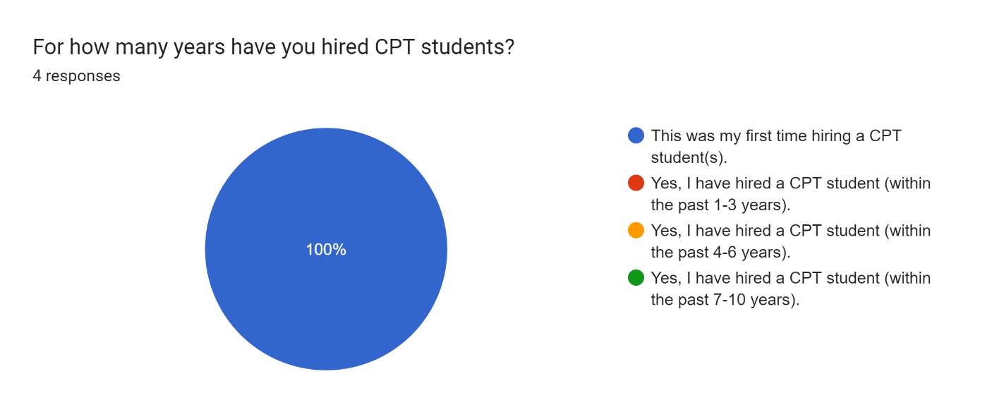

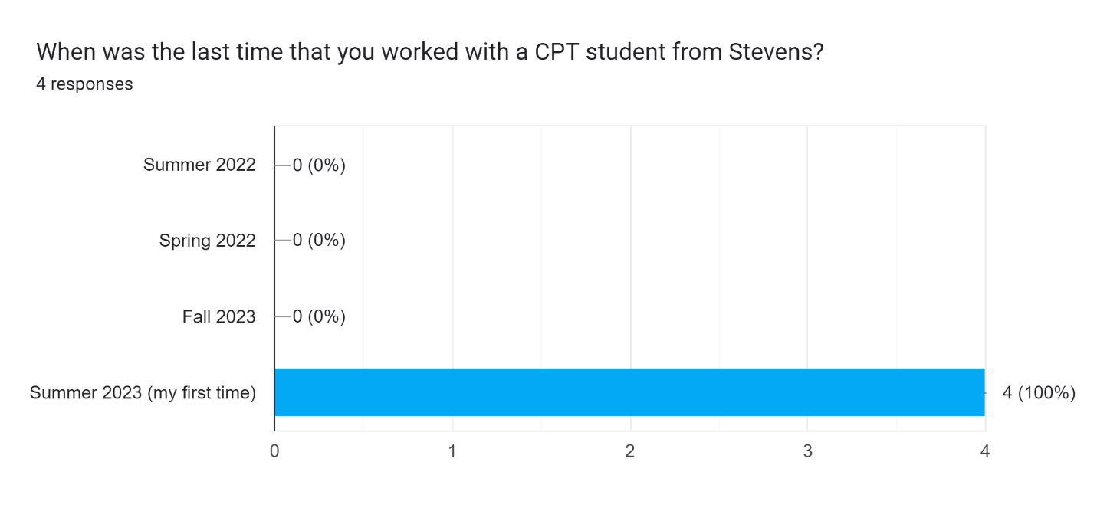

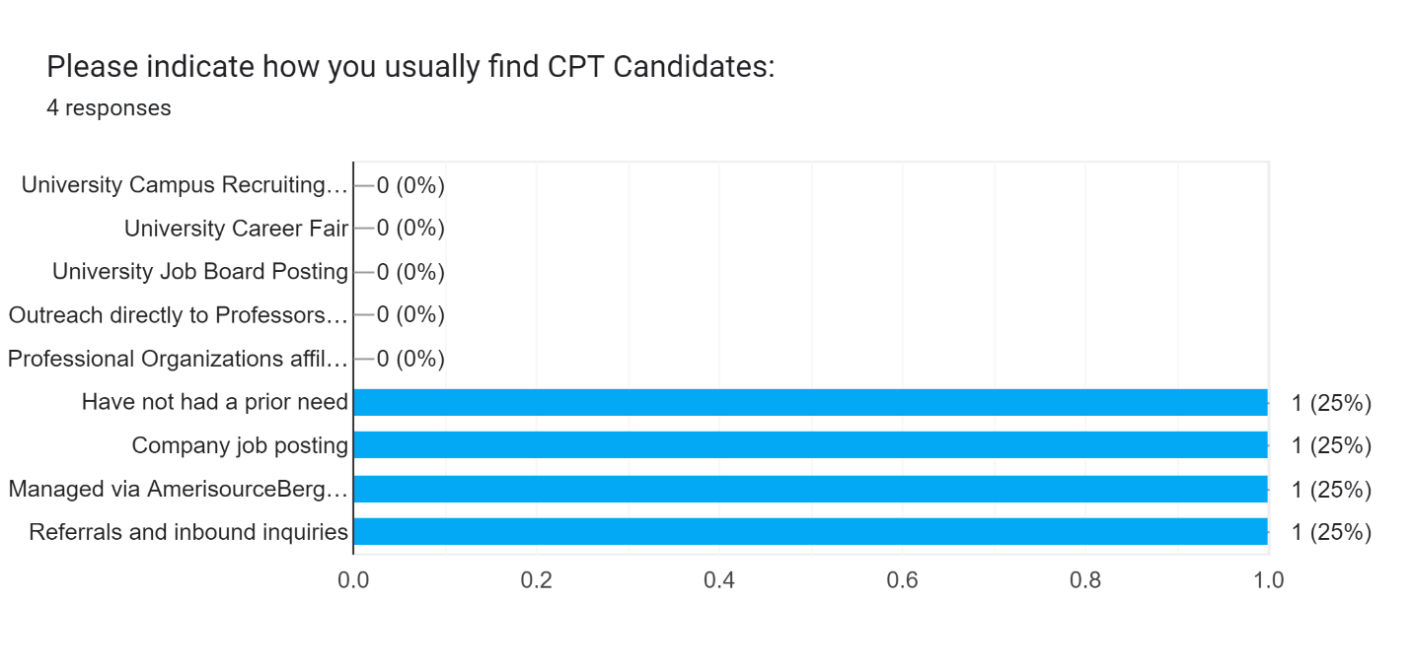

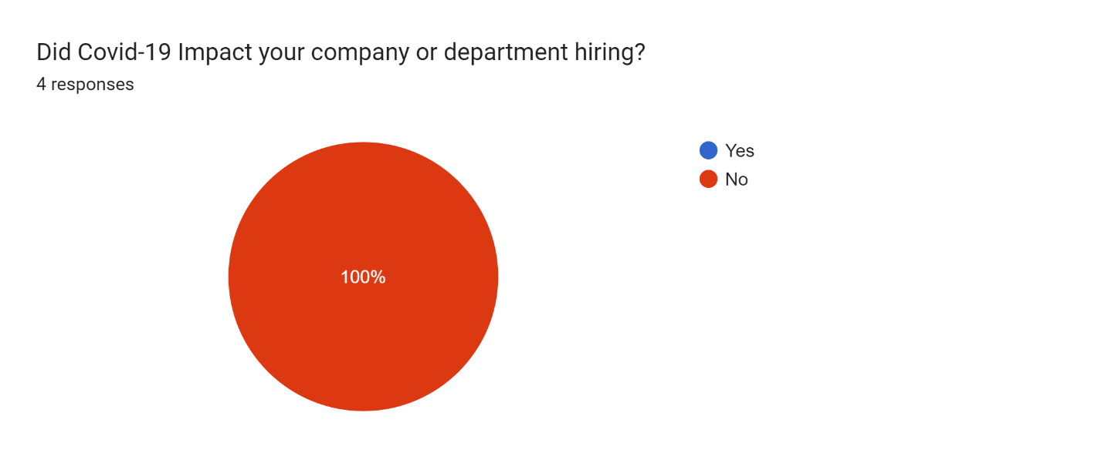

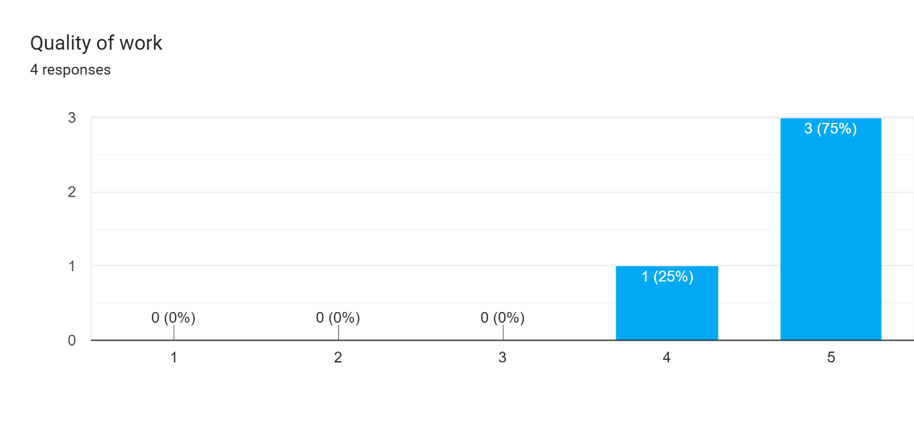

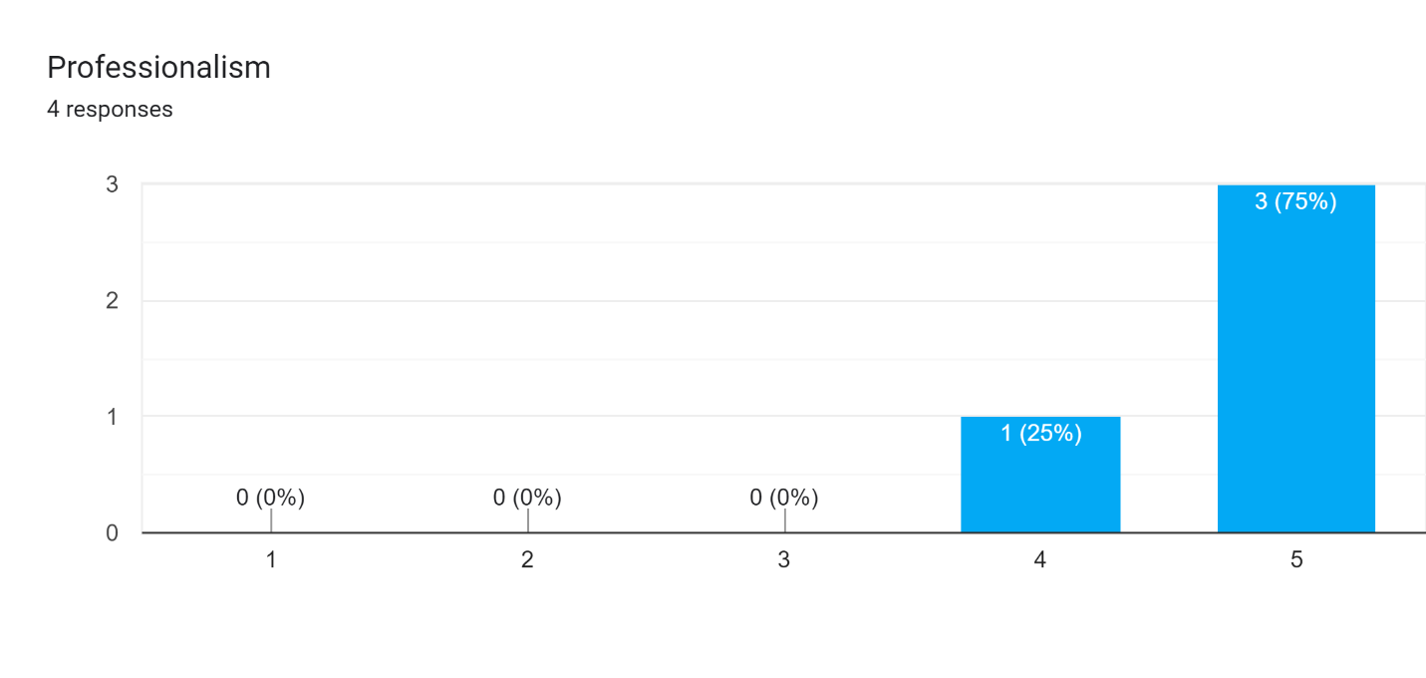

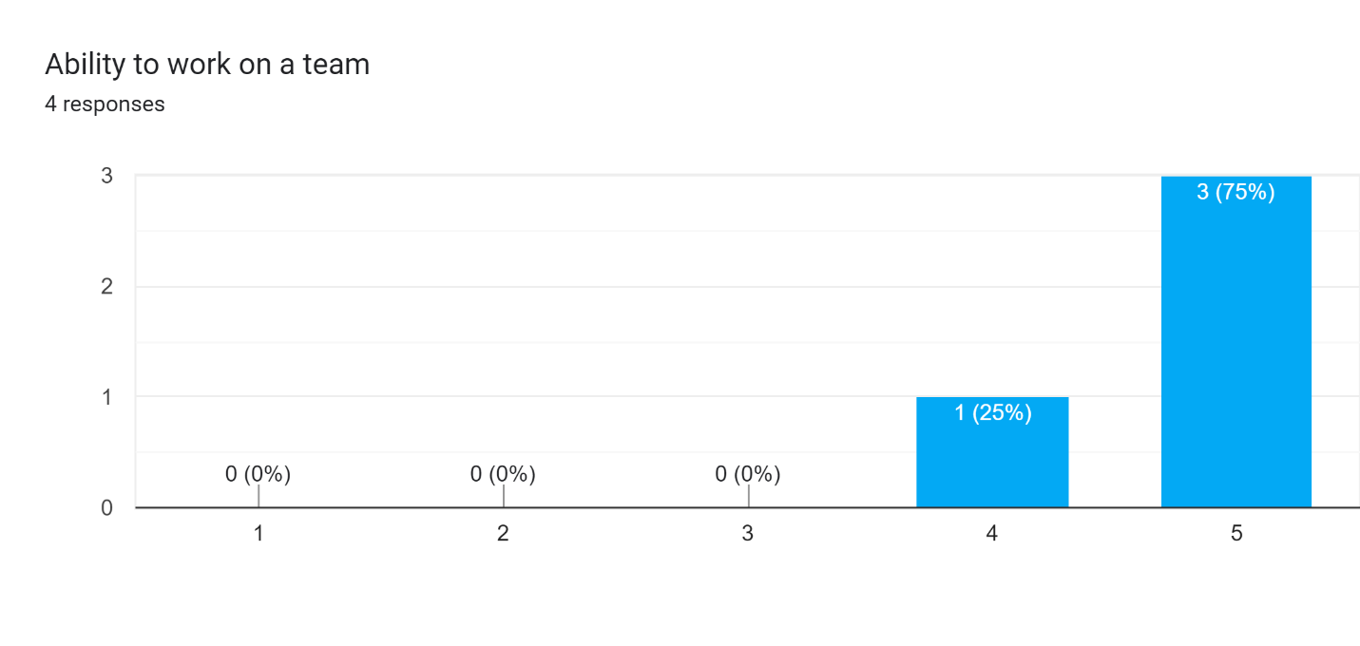

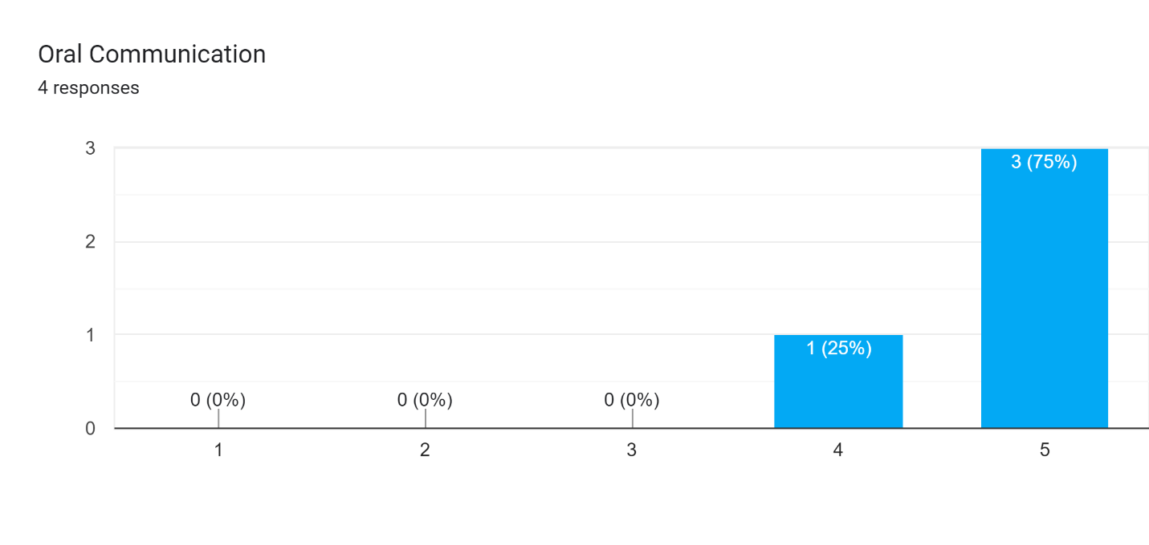

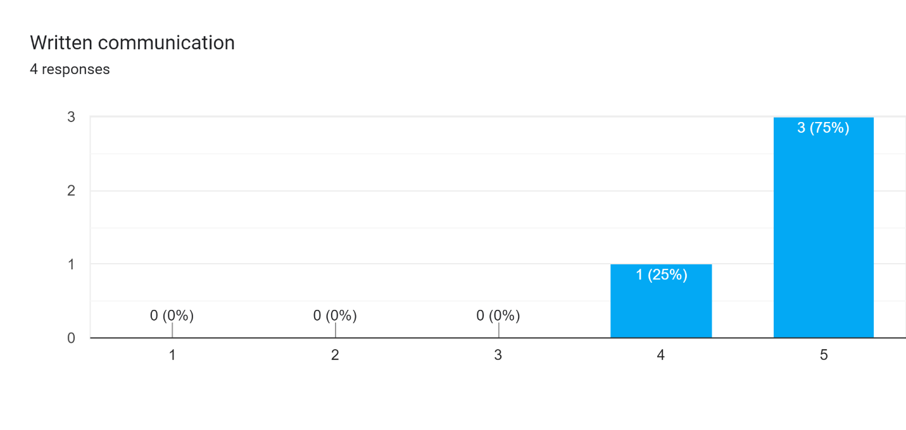

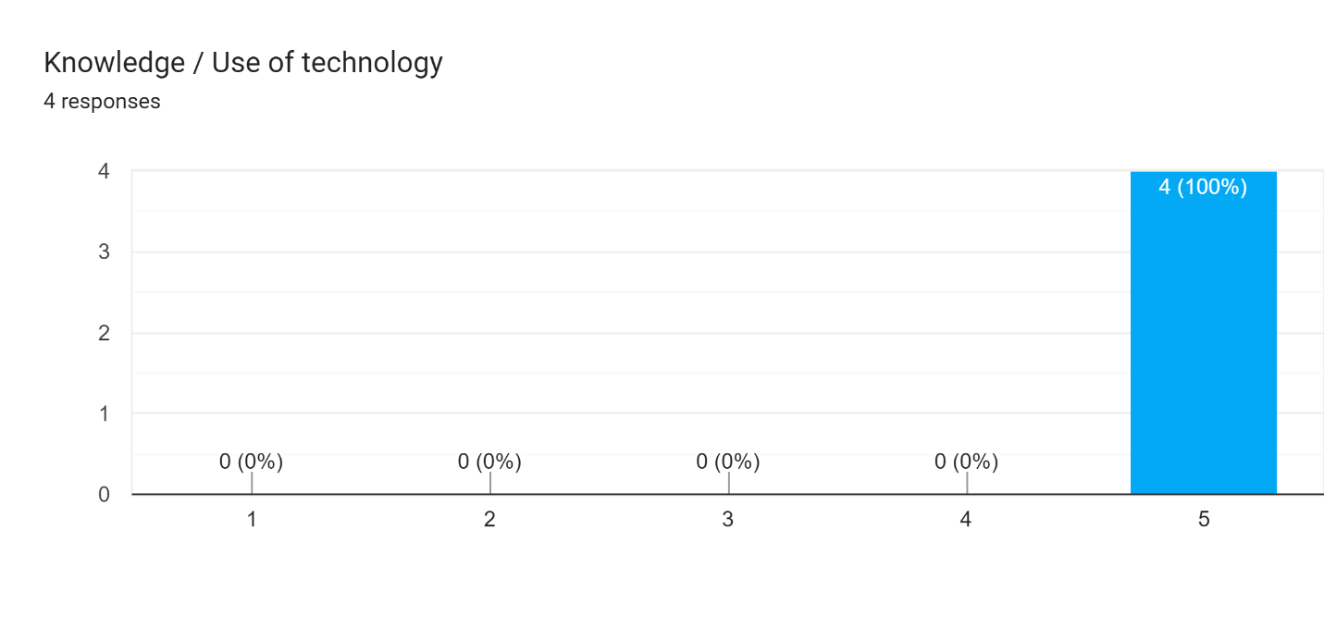

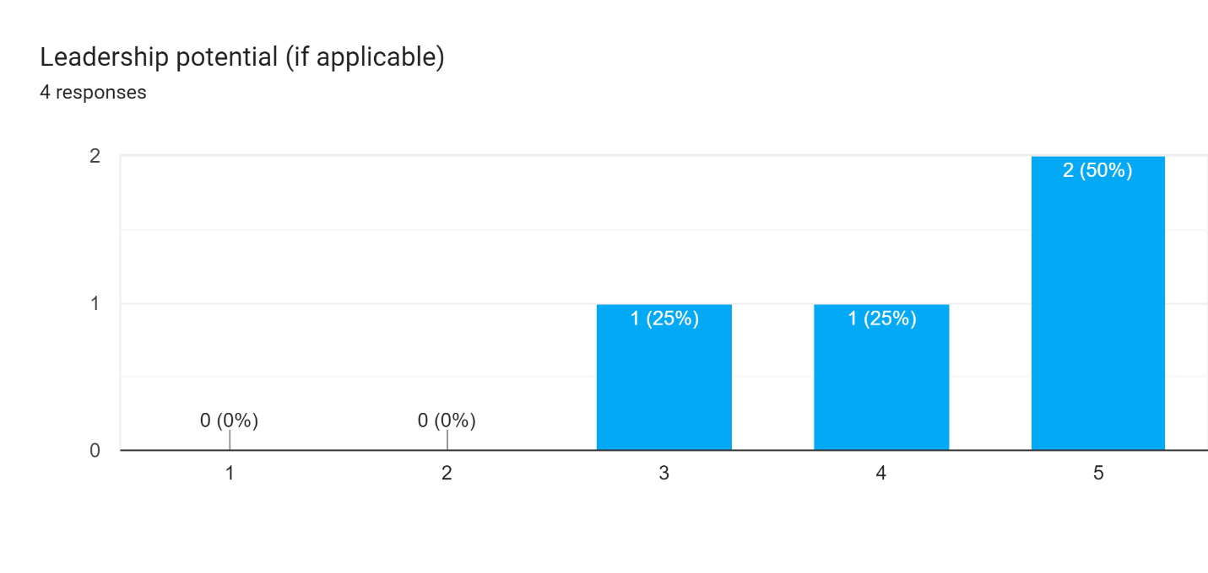

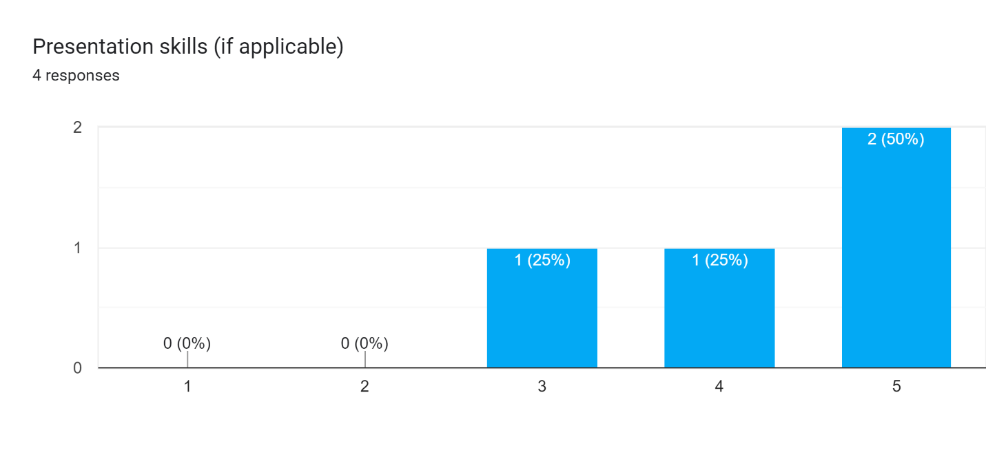

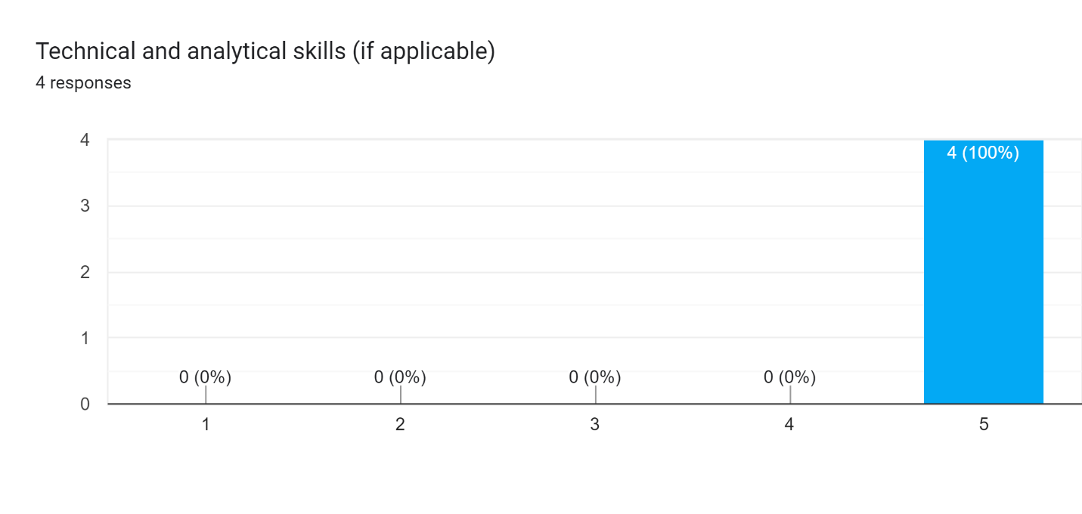

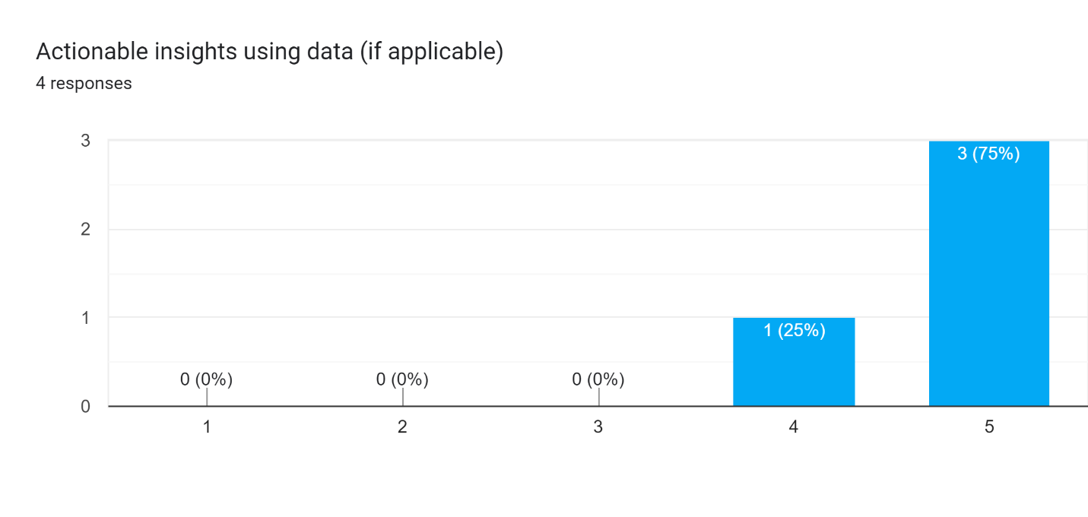

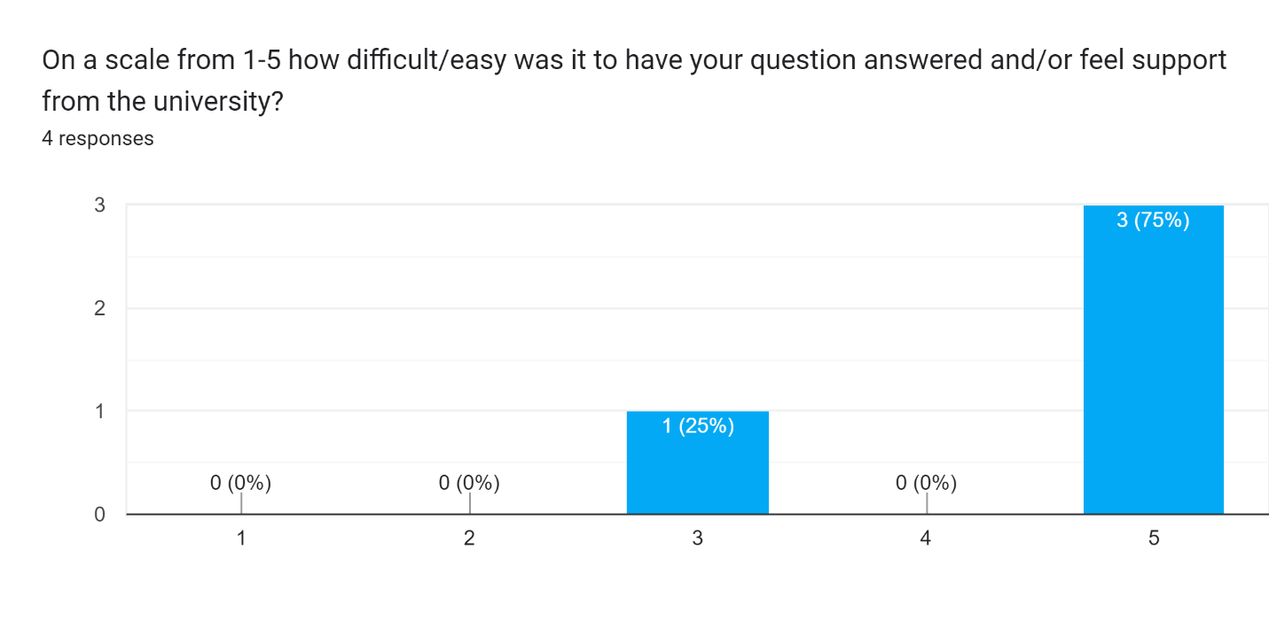

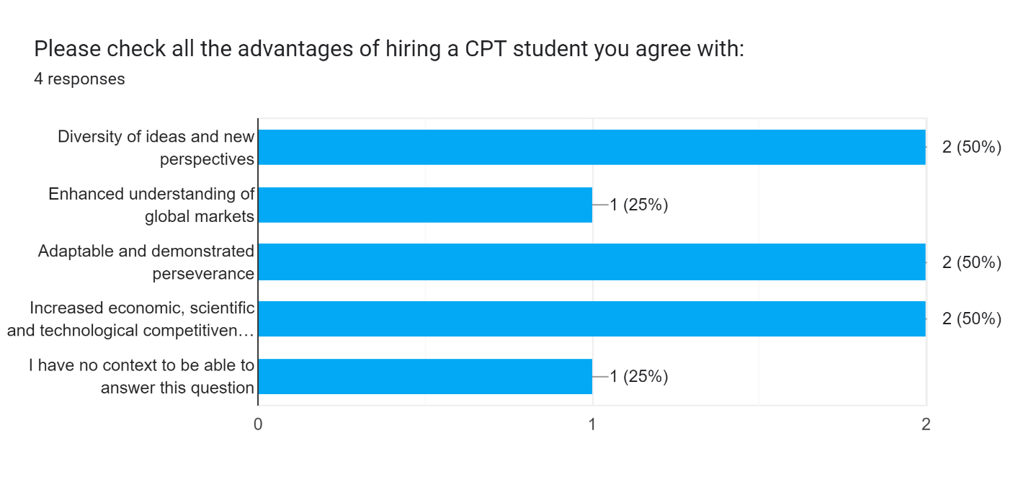

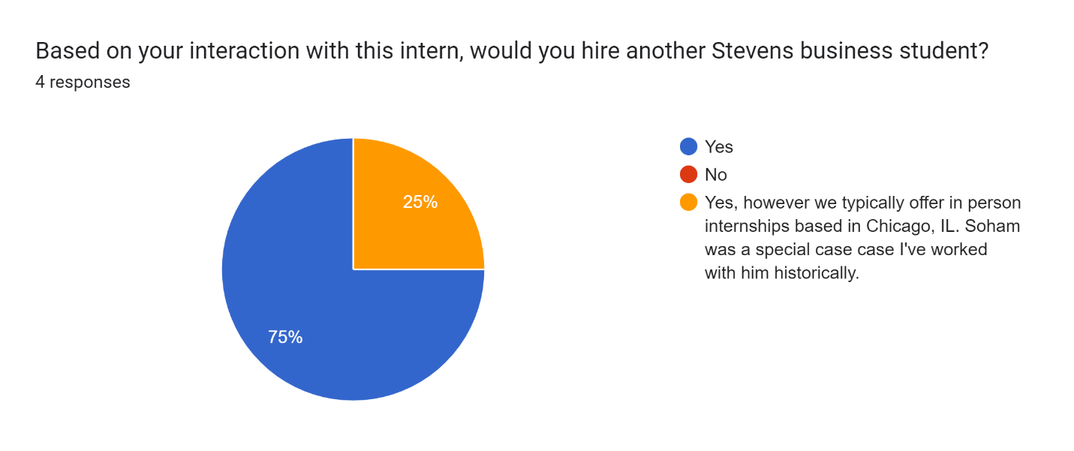

**Spring 2023: CPT Intern Evaluation**

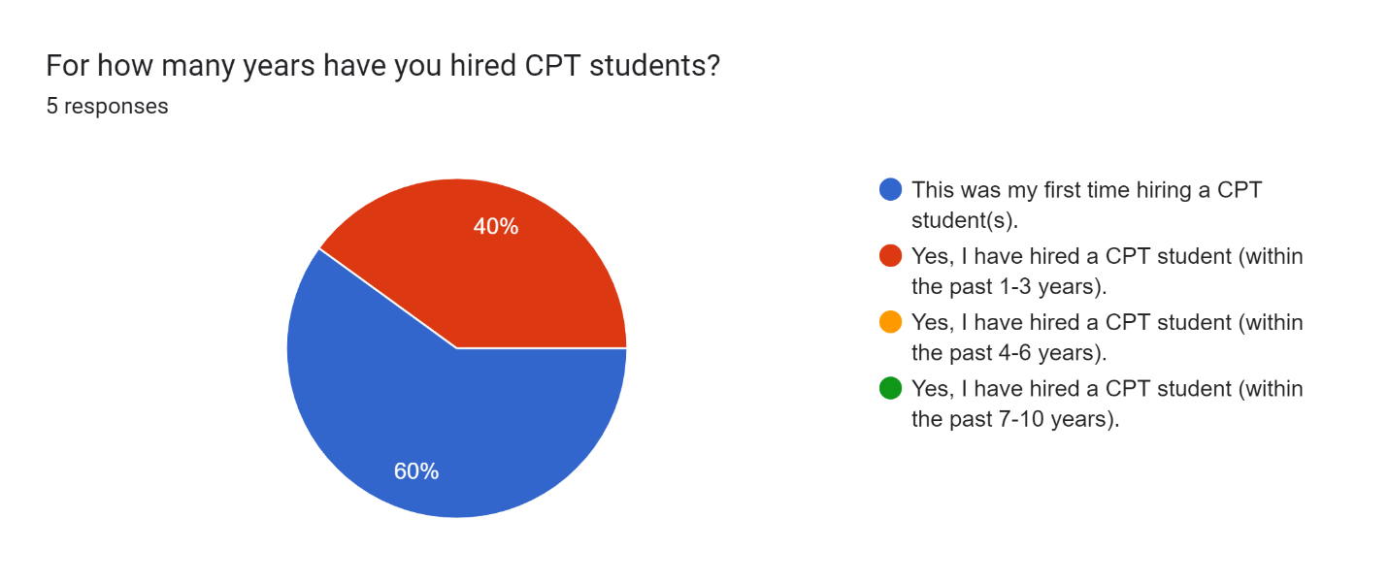

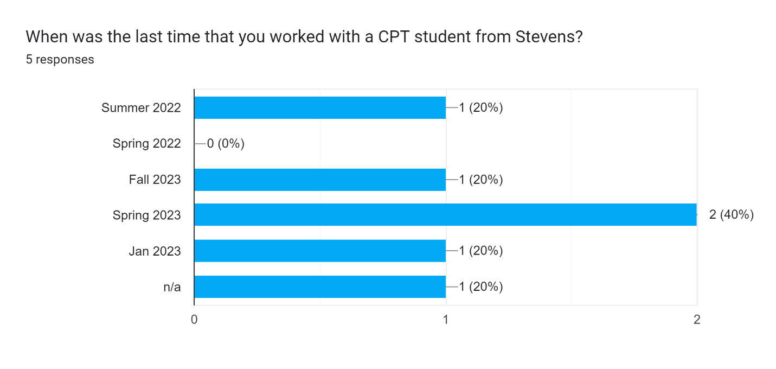

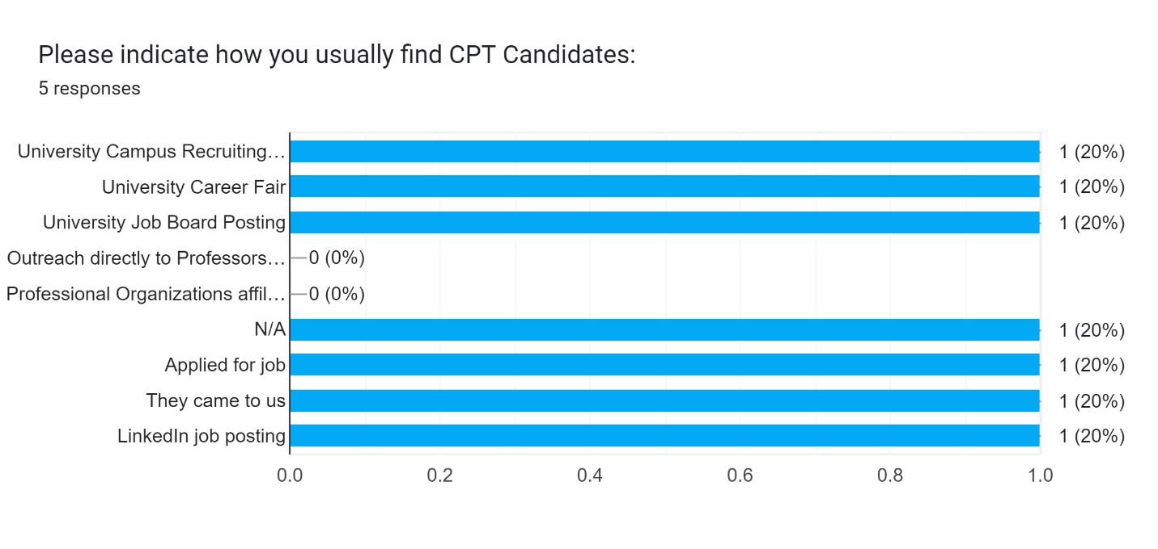

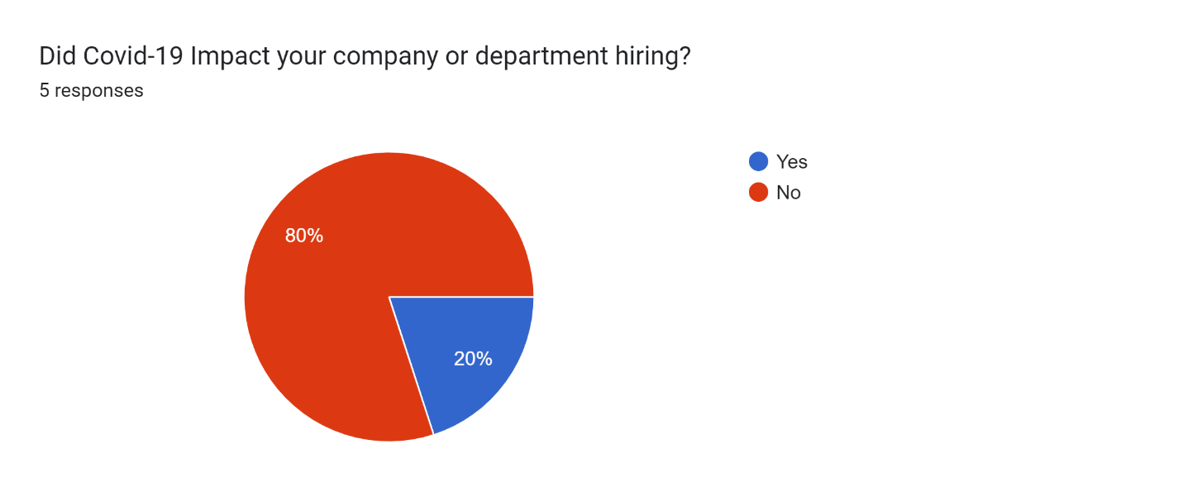

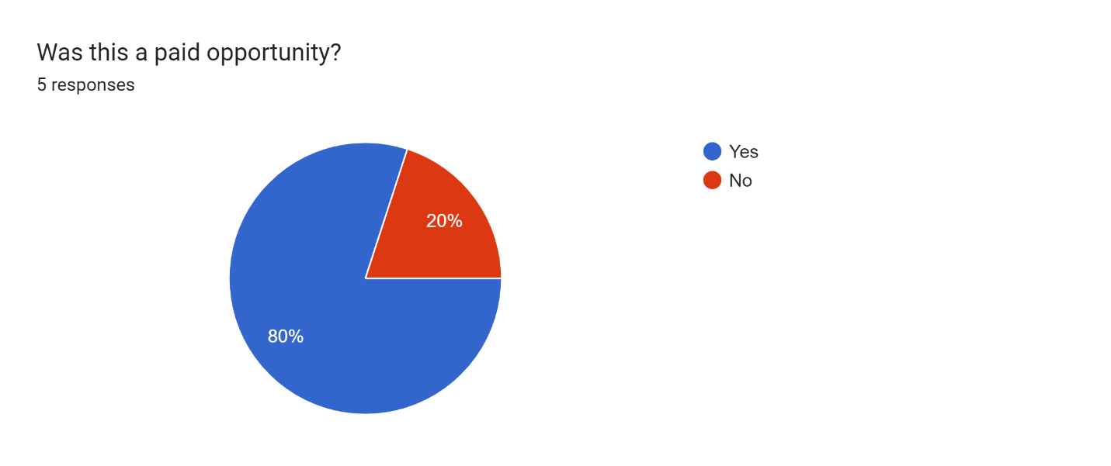

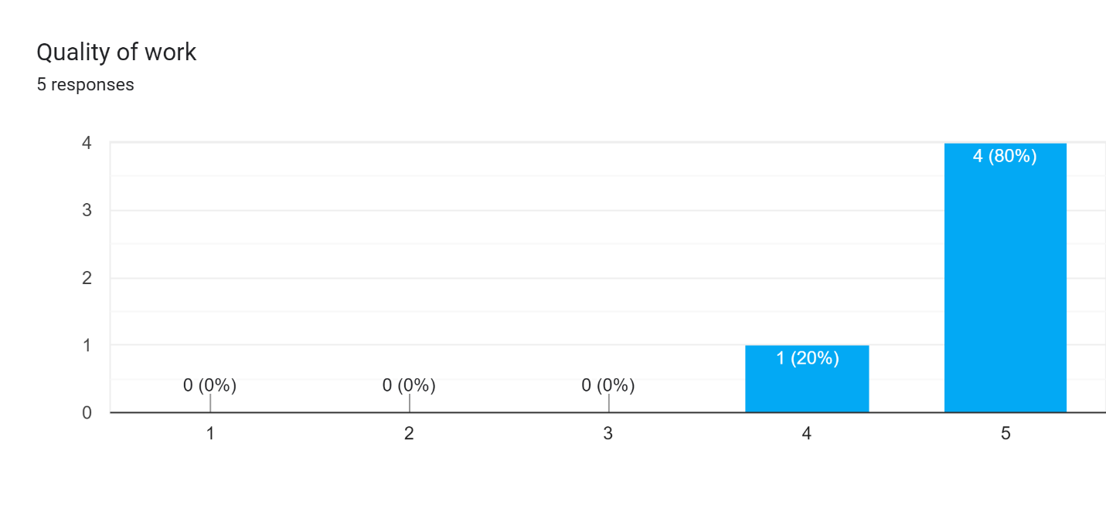

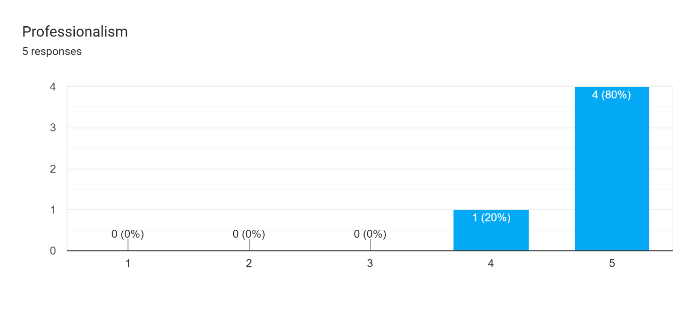

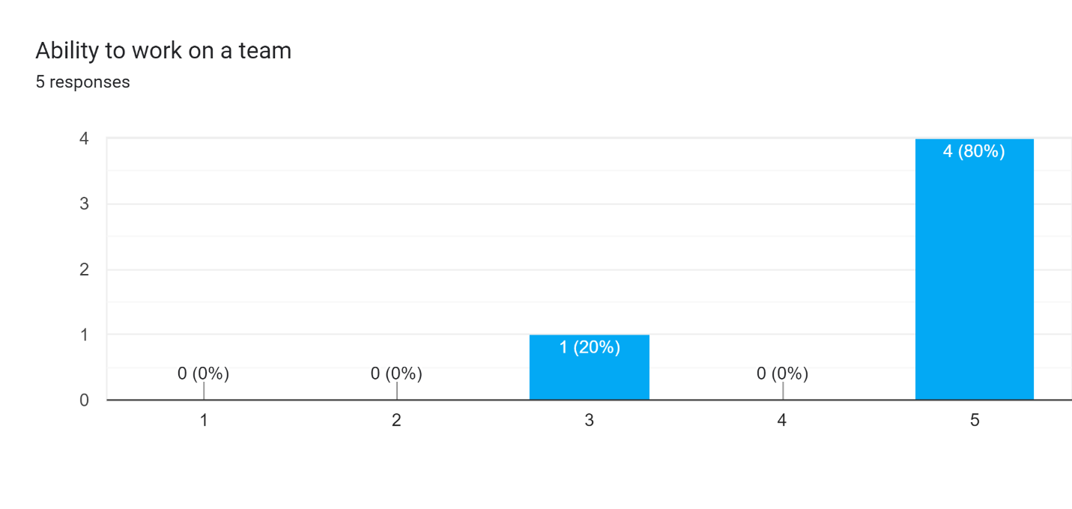

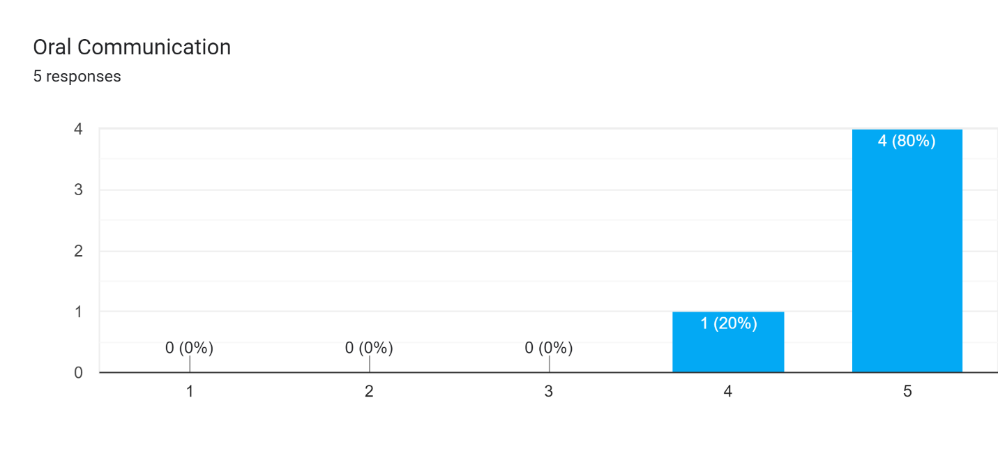

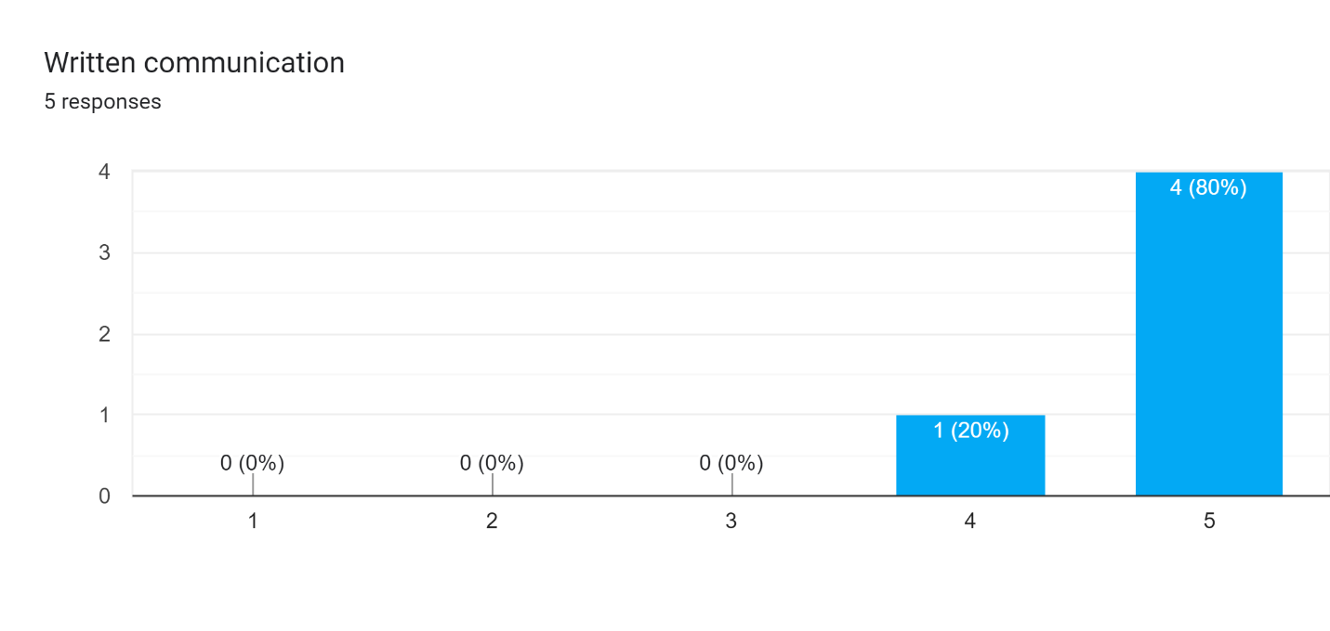

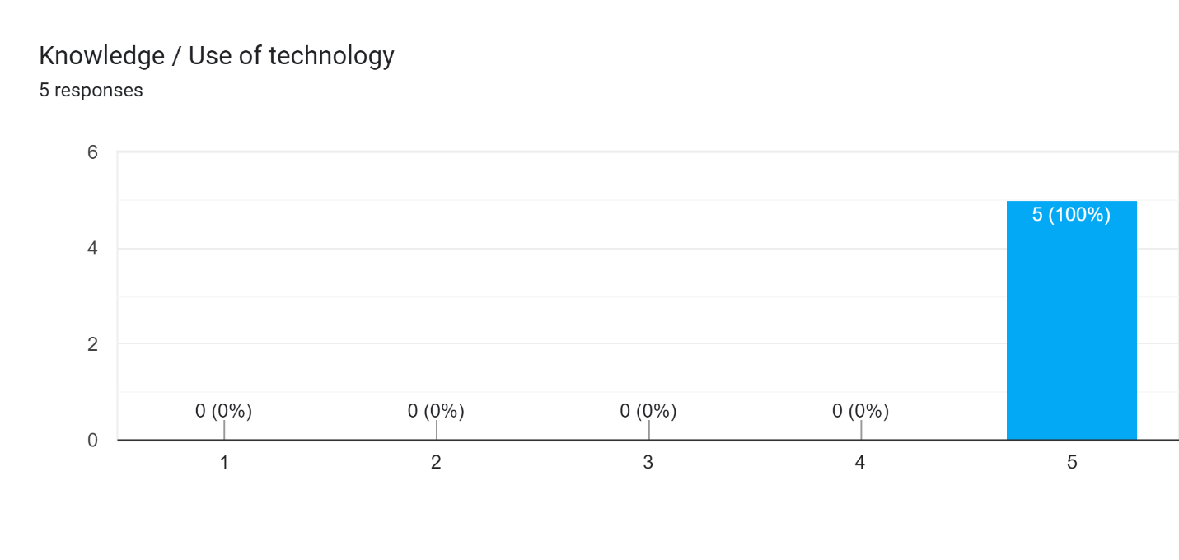

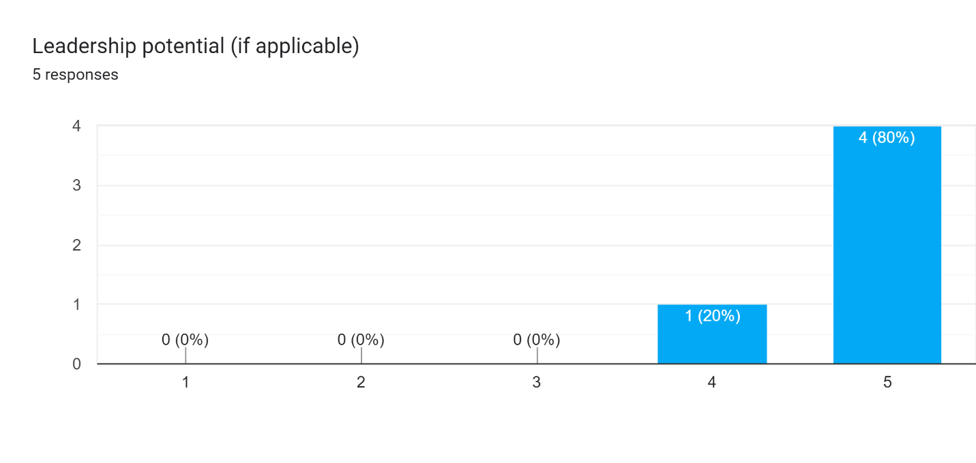

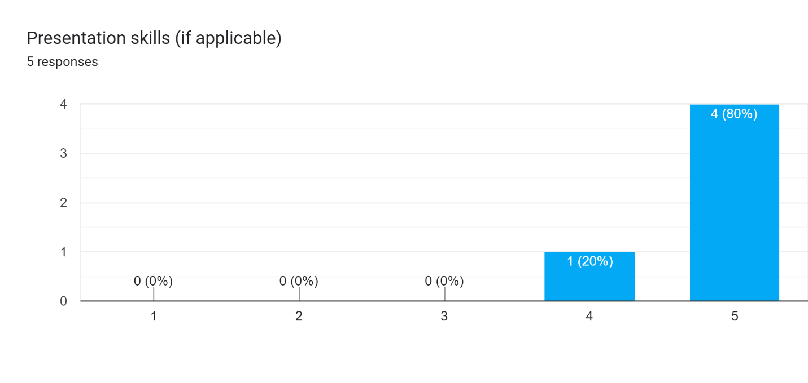

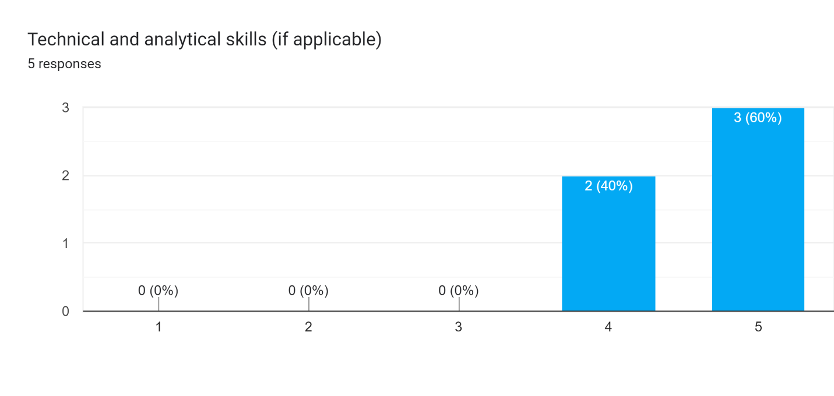

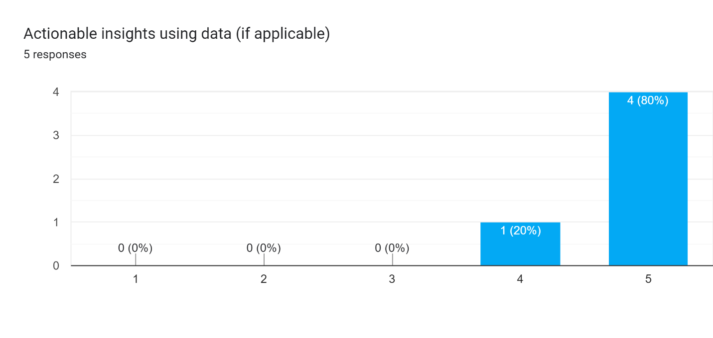

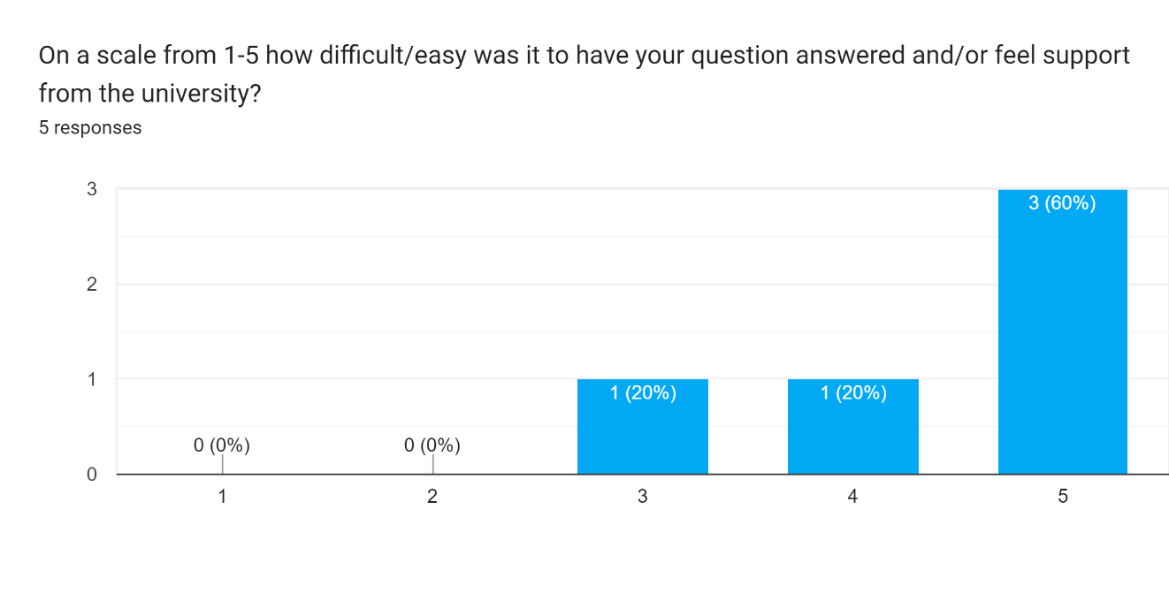

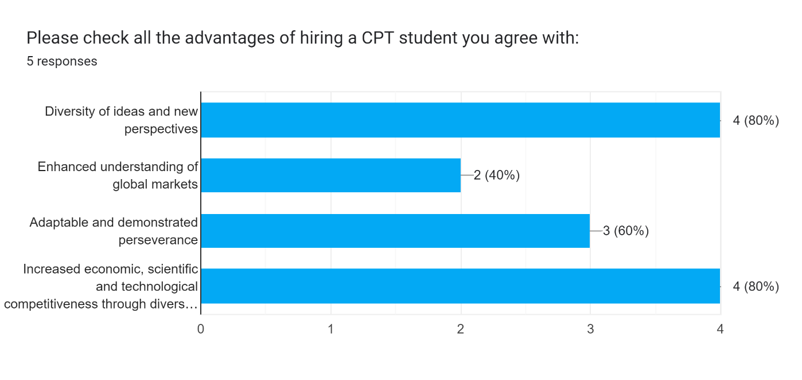

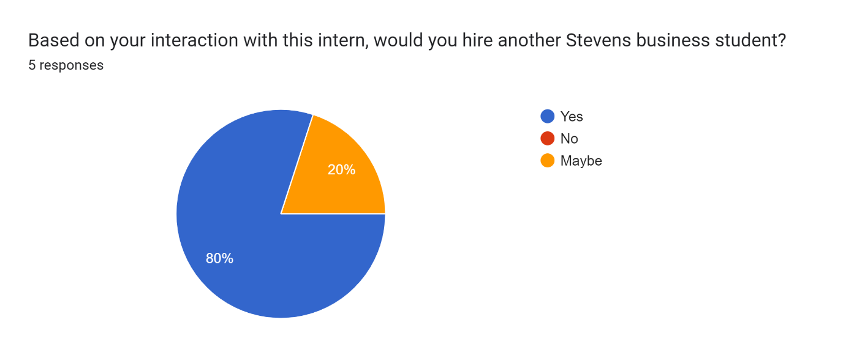

**Fall 2022: CPT Intern Evaluation**

